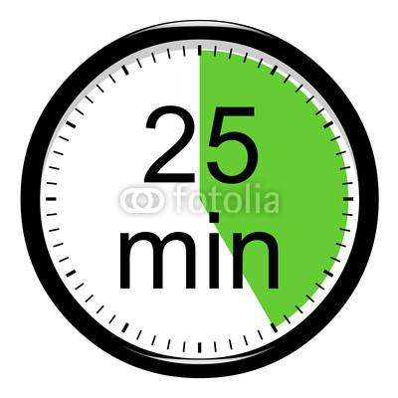

Part A – 25 minutes—Plan the Routine

- Think about your first weeks of math instruction at the start of the school year.

- Select or develop a routine and choose a math task to use with that routine. You may want to consider the following questions as you plan:

- How will you introduce the routine to your students?

- What specific materials or tools (handouts, charts, PowerPoint, song,etc.) do you plan to use to help your students learn the routine?

- How will you model this fabulous routine?

- How does this routine engage students in argumentation?

- You may work with people from your school/district or from your grade level (as you find helpful!)

My Plan…

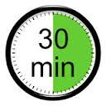

Part B – 30 minutes—Workshop the routines!

- Join your group of 3 (will be selected for you).

- Share your plans and listen to suggestions.

- You will have up to 5 minutes to share and will receive at least 5 minutes of suggestions.

- While listening to ideas and suggestions, please remain silent and focus on writing suggestions.

Suggestions…

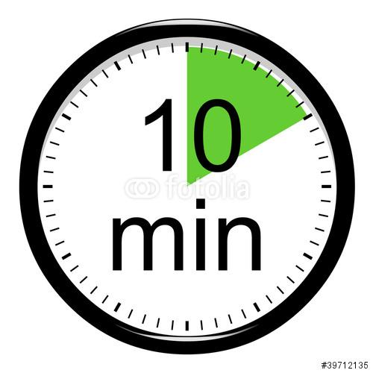
Part C – 10 minutes—Revising the Plan

Reflect on suggestions given by your colleagues to revise your plan, record next steps, ask questions or write other good ideas you heard.

