Is it a Half?
Video Transcript
Clip 1
Brief description of focus of video: This is a 2.5-minute clip. We see two girls working together on a sorting activity where they are to determine whether or not certain shaded rectangles represent ½ or not. A classroom researcher is working with them, asking questions. The clip starts near the beginning of their work together (after place 6 cards) and they have some misconceptions about what ½ means.

CLIP 1: Is it a half?
[The two students and researcher are looking at a paper split in half with one side saying “Half” and one side saying “Not a half.” There are smaller papers with different numbers of boxes shaded in on each side of the line.]
00:05
G1: Nope. Nope. Not even. No.
00:05
R: Do you guys want to…can you explain why when you say it’s not a half?
G1: If it’s a half, it would be like equal parts of the one you just saw.
G2: [pointing to one of the cards on the side labeled “Half”] 1, 2, …
G1: It has to be the same size as this one [pointing to sheet of paper under “Half” side]
R: It has to be the same size as that one on each side?

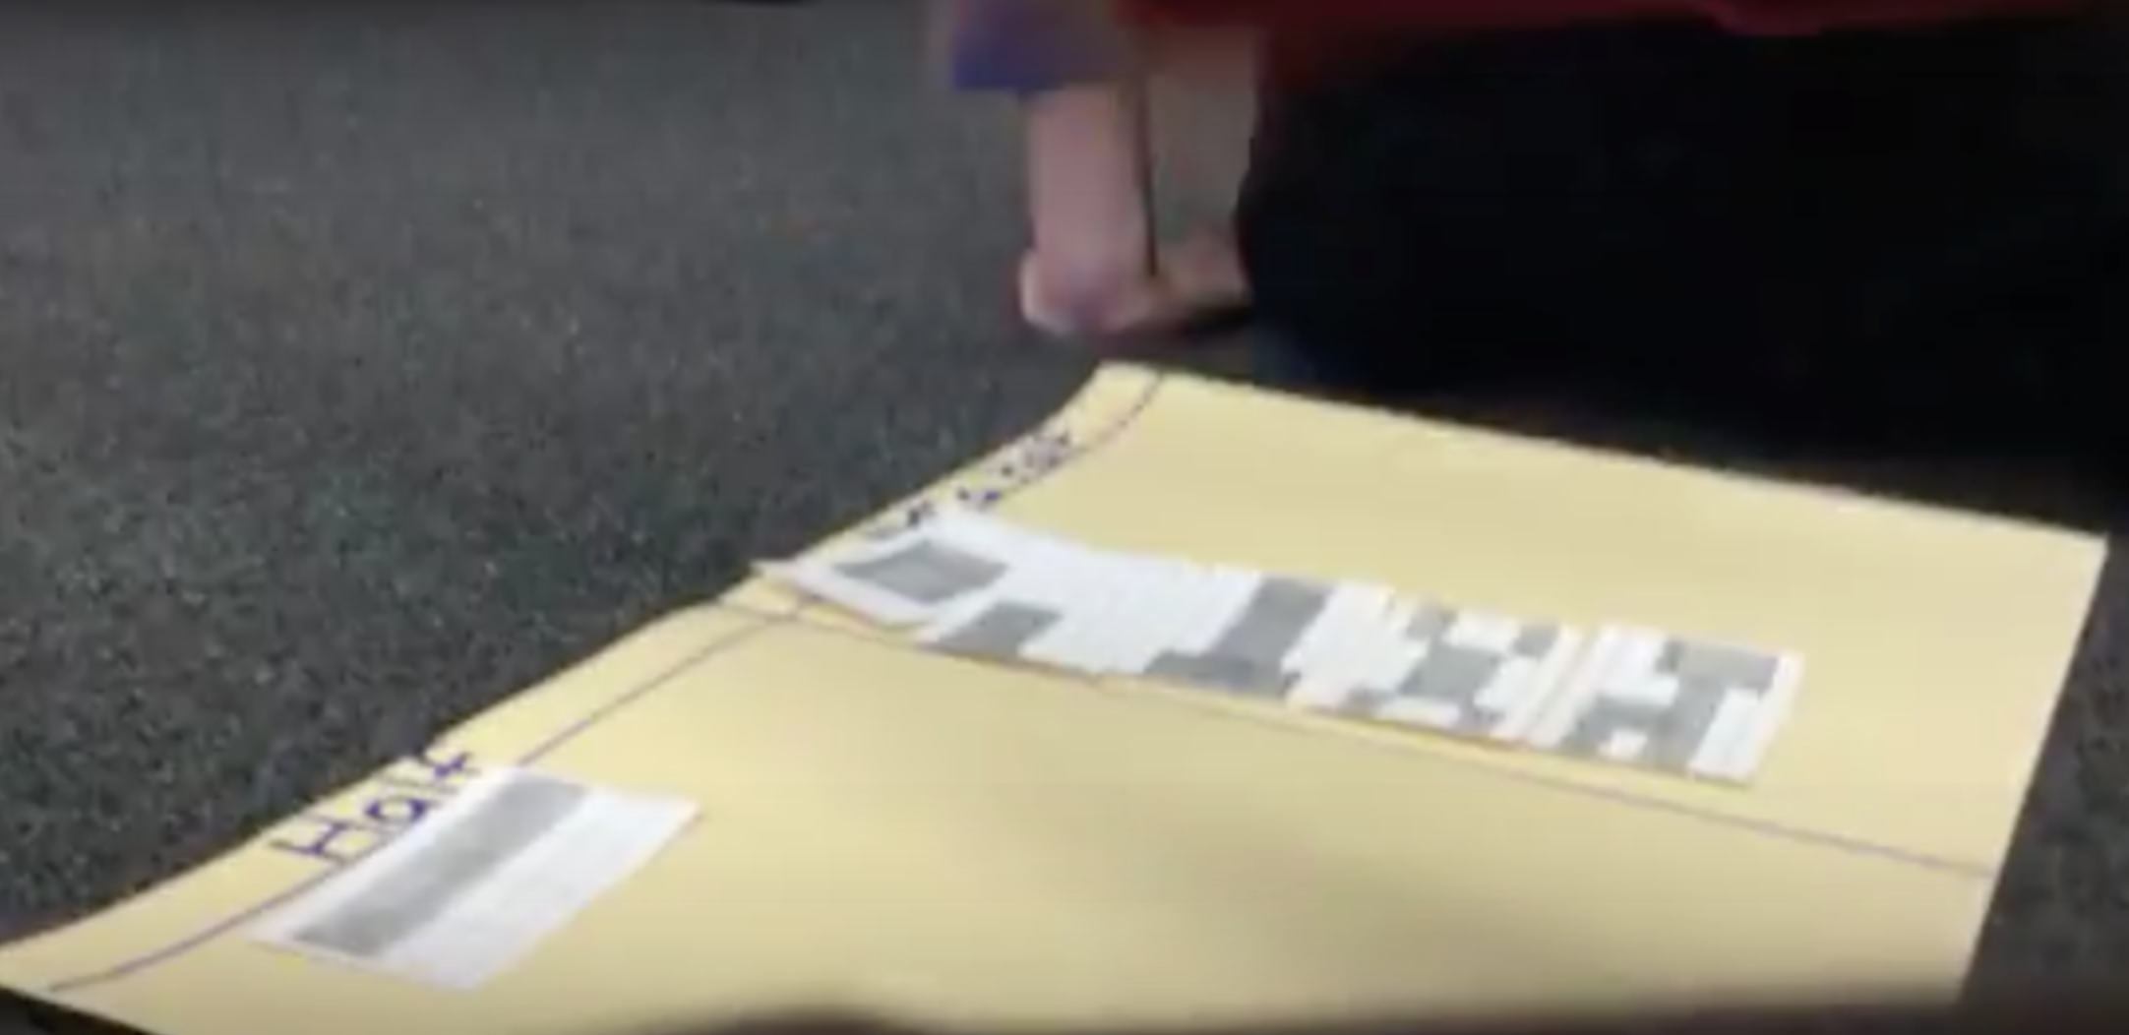
G1 and G2: Yeah.
00:25
R: So, this one’s a little more obvious, right? Can you explain why that’s not a half maybe you want to do?
G1: That’s not a half because it has to go all the way or else it’s just covering the whole thing.
G2: Well, could it be like, could it cover this side too…to be a half too?
G1: Yeah.
R: Okay, so you guys agree if it covered either of those ways it would be a half?
G1: Because that’s 6 and that’s 6 [points to a paper under the “not a half” column]
00:49
R: Oh that’s interesting. Okay, so what about this one? [points to the first card in the “not a half” column, recreated here] If you don’t mind me asking about this one here.

G1: That’s not it because these two have to be together.
[G1 points to two columns of un-shaded blocks on the sheet of paper and motions they should be next to each other.]
R: Okay, would you say…so, could you possibly say that because…
G1: Because half has only 2 sides, that has 3 sides.
01:10
R: Ohhh, that’s a really interesting idea: half has to have 2 sides, but not 3 sides. That’s really interesting. So in math..it’s a little…I see what you’re saying because things like half moon that you talked about, you can’t have the middle slice. In math, you can have half of something if it just equals half of the area.
01:30
G1: Yeah.
G2: Ohhhh.
R: So, it doesn’t matter. So, let’s slow down just a little. So, it doesn’t matter if it’s exactly two sides, but if it’s half of the area. So let’s look at this one.
[R points to the paper on top of the “Not a half” column]
R: And let’s decide…we have to argue either it’s not half of the area, or it is half of the area. Because just saying it’s not split in two sides doesn’t convince us yet. Okay? So…
G1: [pointing to the sheet of paper] Well, it has to be like that. It has to be the same as these two but they’re still not.
01:59
R: Still not what? You’re saying that they’re…
G1: Still not the half.
R: Still not the half? Can you tell me about the area though? Because that’s going to be the most important part.
G1: Area, well, they do have the same area.
R: What has the same area?
G1: These white ones. [points to un-shaded regions on either side of shaded block in the center of paper]
G2: They have to be…[inaudible]
R: Okay, so you’re saying that…so what has the same area?
G2: Umm.. these two have the same area [pointing to shaded blocks] but these don’t [pointing to un-shaded blocks]. So that’s why it’s not equal.
02:25
G1: They have to be together [pointing at white, un-shaded regions].
R: They have to be together. Okay, so we need to, I need to find a piece of paper or something.
02:32

Clip 2
What makes something ½? (Especially when it doesn’t “look like it”?)
00:06 – 2:33
R: [drawing squares and splitting them into 4 smaller squares] Okay, so I think you guys agree if I do this and shade over here [shades 2 out of the 4 smaller squares in the square] you are going to tell me half is shaded.
G1 and G2: Yeah.
R: Okay you agree to that. Now what if I go like this [draws another square] and I cut it into 4 again [splits square into 4 smaller squares] and I do this and this [shades 2 smaller squares in the square that are not next to one another]. Is half of the area of that square shaded?
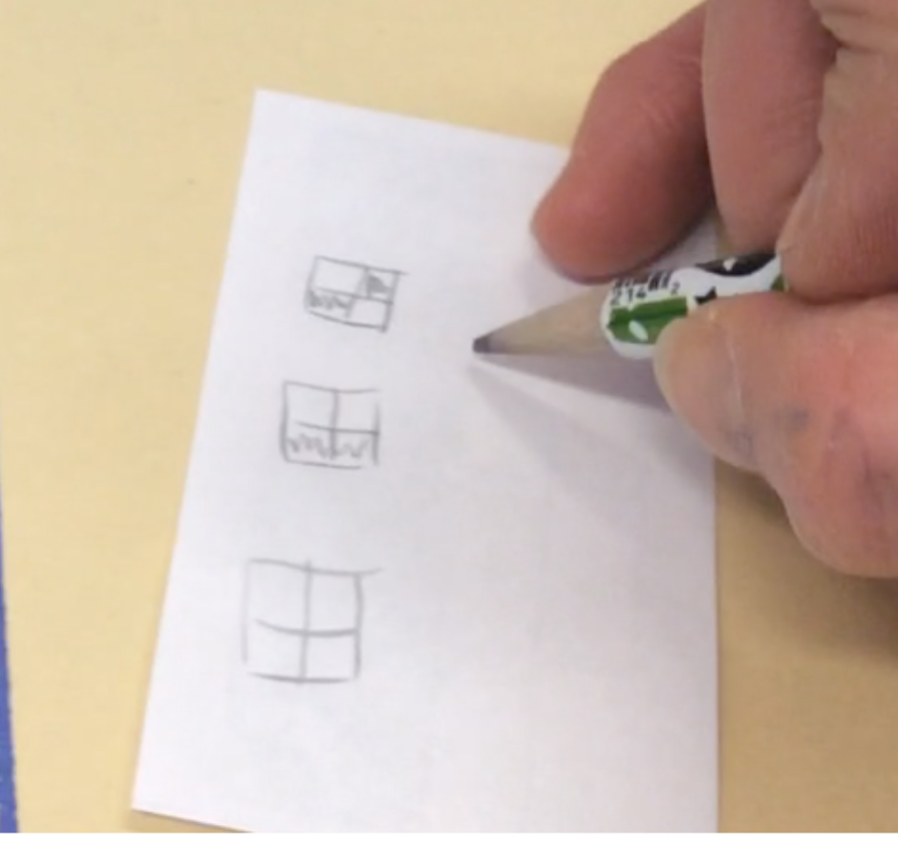
G1: Well actually it is because that is the same size as that one. [pointing to smaller squares within square]
00:30
R: [inaudible] piece together are the same size?
G1: Well, no it’s still not half. Because…
G2: Because they have to be the same size, same shape,….
R: Oh, but if I do my shaded pieces, there’s two. You see those are the shaded pieces? [draws the two shaded smaller squares on their own outside of the larger square]
G1 and G2: Oh yeah.
R: And the nonshaded is like this at least, right? [draws nonshaded smaller squares on their own outside of the larger square]
G1: Oh yeah. So it is half.
01:00
R: It is half in that case. [G1 has picked up a card that had been in Not A Half] Now, so are you now agreeing this one is half, too?
G1: Yeah. She agrees [referring to G2].
R: [asking G2] Okay so what do you think? You’re not sure yet?
G2: It looks like it.
R: It looks like it. So the way we decide half is going to be based on area.
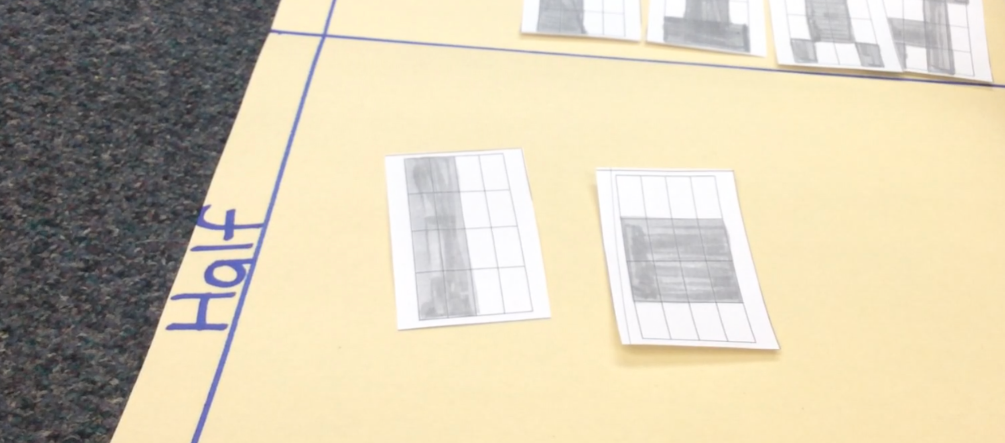
G2: Actually, it kind of makes sense because these two are together [pointing to shaded region from previous example] and these two are together [pointing to shaded region from original example]. These two may not be together [pointing to nonshaded from original example] but that still doesn’t mean it has to be.
G1: Yeah, but it would make more sense if they’re together. But, it can still be like that.
R: Okay, cool. Okay, well keep going. What’s the next one you want to do?
G1: That one’s not equal. [pointing to new example]
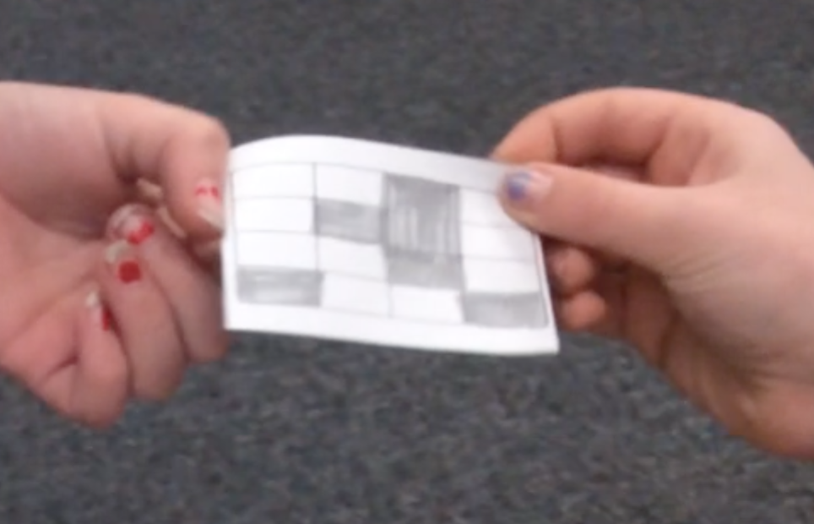
G2: Yeah, because it’s all like over the place [pointing to shaded squares that are not all touching]. [G1: It’s all over the place.] And, and there’s one like one [inaudible] shaded and one [inaudible] shaded…
G1: When you see it you should know what it was.
01:45
R: So, just by looking at it, it doesn’t look like the same amount of area is shaded as not shaded, but how could we know for sure? Because it’s really hard to tell.
G1: We could actually count. 1, 2, 3, 4, 5, 6 [counting the shaded squares on the paper] 1, 2, 3, 4, 5, 6, 7 [counting the unshaded squares on the paper]. You already know you’re over so that means it is not going to be a half.
2:05
R: Oh, okay. Alright. Can we go back to this one if you don’t mind, now that we’re understanding something new about areas and what half means? [points to previous example]. What do you think this one is?
G2: I think that looks equal.
R: You think that looks equal?
G1: 1, 2, 3, 4, 5, 6, 7, 8 [counting shaded boxes on example]. 1, 2, 3, 4, 5, 6, 7, 8 [counting unshaded boxes on example]. It’s equal.
G2: I think that looks equal.
02:20
R: You’re saying it’s equal now?
G1: It’s because these two are the same as that [pointing to nonshaded and shaded boxes]. If you just put them in the right order then it would make sense.
R: Okay, go ahead Cat what were you going to say.
G2: It’s because there’s two here, two there and two here [pointing to shaded boxes] and that’s probably why it’s equal because there’s like two in each column.
G1: I agree with you.
2:41

