Small Routines to Support Argumentation
How Do You Know? - - - - - - - - - - - - - - - - - - - - - - - - - - - - - -
Are the two triangles congruent? How do you know?

Eliminate It - - - - - - - - - - - - - - - - - - - - - - - - - - - - - - - - - - - - -

Cross out the function that does not belong. Create a mathematical argument to support your decision.

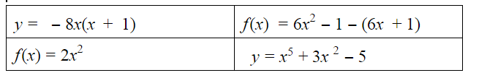

Would you rather? - - - - - - - - - - - - - - - - - - - - - - - - - - - - - - -
Create a mathematical argument to support your decision.

