Intro to Argumentation
Objective: Students will be able to identify a claim, evidence, warrant, in an argument as well as use them in their own arguments.
Intro: Briefly discuss “Arguments”.
- Have you ever had an argument or disagreed with someone?
- How did you try to prove you were correct?
- What made your argument/their argument better?
Lesson: Today we will talk specifically about the different parts of an argument and how to make an effective argument.
- Discuss the parts of an argument.
  - Claim – stated stance on an argument
  - Evidence – an example supporting your claim
  - Warrant – a law or truth that is already known that supports your claim (previously established ideas and facts)
  - Possibly: Chain of reasoning – links evidence to support claim
- Activity: “Jimmy And The Pizza”- Students decide if they think Jimmy is guilty, and identify the parts of argumentation they use
  - Claims: Possible claims
    - Jimmy is innocent and did not eat the pizza
    - Jimmy is guilty and ate the pizza
  - Evidence: Possible evidence
    - Jimmy is doing dishes
    - There is a used juice box on the kitchen table
    - Jimmy looks guilty
    - The pizza is in the trash can
    - There is pizza on the floor
  - Warrants:
    - Jimmy does not like doing dishes
    - He is supposed to eat a healthy snack
    - Jimmy would not look guilty if he was not guilty
- Closing – Discuss what made arguments effective
  - Who had a clear claim/why it is important
  - The role evidence played in supporting arguments
  - How warrants helped interpret evidence

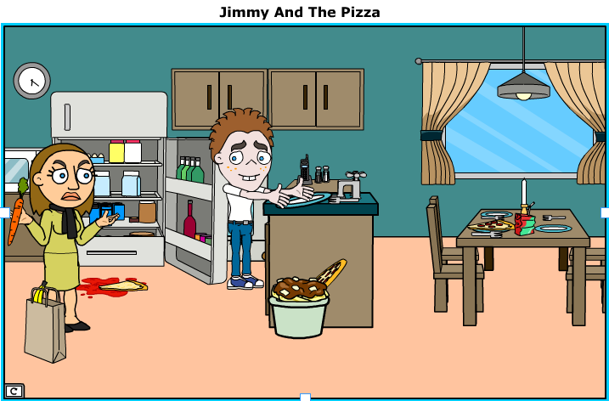
Jimmy is a 6th grade student who absolutely LOVES pizza and hates doing dishes. Jimmy’s mom, Mrs. Morales, has always told jimmy that pizza is only allowed as a special dinner food on Friday nights, and he is only allowed to have healthy foods for afterschool snacks.
Jimmy’s mom always leaves a healthy snack in the refrigerator for him to eat after school. On this particular day, Mrs. Morales did not have any healthy snacks left in the house so she briefly left to get some from the supermarket. While she was gone, Jimmy arrived home and checked the refrigerator for his healthy snack.
Soon after, Mrs. Morales came back from the supermarket to find some leftover pizza spilled on the floor and Jimmy doing the dishes. Jimmy said that when he checked the refrigerator for his snack, the pizza fell out and onto the floor.

Name ____________________ Date ____________
Introduction to Argumentation

Jimmy and the Pizza
Claim:
Jimmy is __________________ (innocent/guilty).
Jimmy _________________ did/did not eat the pizza.

Evidence:
- .
- .
- .

Warrants:
- .
- .
- .

