Good Luck to _________________________ Parts of a Triangle Quiz C

For each of the following, choose the best answer. (1 pt each)

1. What is the measure of the vertex angle of an isosceles triangle if each base angle measure 38˚?
2. 19
3. 76
4. 104
5. None of the above
6. Find the values of x and y

|  |  |
| --- | --- |
| http://www.classzone.com/etest/getExhibit.htm?exhibitId=92049 | 1. x = 72˚ ; y = 54˚ 2. x = 54˚; y = 72˚ 3. x=54˚; y = 63˚ 4. x=63˚; y = 54˚ |

1. The centroid of a triangle is the intersection of the :
2. Altitudes
3. Medians
4. Angle bisectors
5. Perpendicular bisectors
6. None of the above
7. How many obtuse angles can a right triangle have?
8. 3
9. 2
10. 1
11. 0
12. Use the figure below, In GK = ______

|  |  |
| --- | --- |
| http://www.classzone.com/etest/getExhibit.htm?exhibitId=176734 | 2. 2FH |
|  |  |

1. 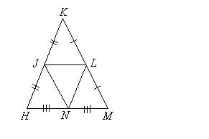In J, L and N are midpoints of the sides. Therefore, $\overline{JN}$// ______ (1 pt)
2. Use the following figure to answer the questions below

y

3x +6 60˚

1. What is the value of x? (2 pts)
2. What is the value of y? (1 pt)
3. Classify the triangle by its angles(obtuse, acute or right) and by its sides(scalene, isosceles, equilateral). (2 pts)
4. Use the triangle below. What would the value of x be if the triangle below is equilateral? (2 pts)

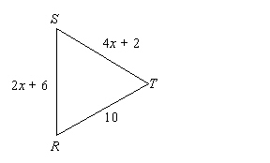

1. In $∆HKM,$ J, L, and N are midpoints of the sides. If JH = 9, HN = 7, and LM = 8, what is the perimeter of $∆JLN?$ (2 pts)



1. In $∆ACE$, if CE = 4x + 2 and BF = 3x -1, then what is DE? (2 pts)

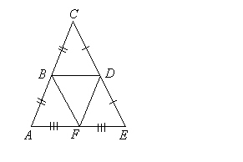

Using the diagram, solve for the missing angle measures:

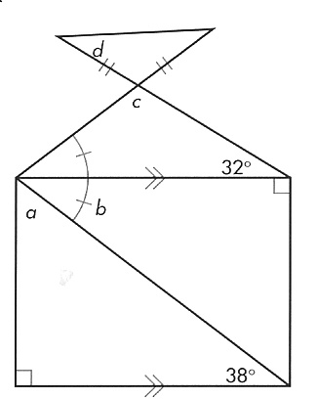

11. m∡a

*b*

12. m∡b

13. m∡c

14. m∡d

1. You are designing a courtyard on a college campus. You draw the courtyard on a coordinate plane and label points as shown below. Each unit in the coordinate plane represents one square yards and the points X, Y, and Z represent the midpoints of the line segments. The college wants three new walkways added and a statue placed at the intersection of the three walkways. You decide to place the three walkways along the medians of the triangle.



1. X is located at (3,4); Y is located at (6,1). Find the coordinates of Z. Verify using algebra. (2 pts)
2. Approximate the coordinates where the statue is to be placed. What does this coordinate represent? (2 pts)
3. The distance from A to B is 10 yards, and the distance from B to C is 8.5 yards. Find the distance from C to A and the total distance around the courtyard. (1 point each)  
     
   C to A:   
     
   Total Distance: