Name: _________________________________________ Date: ___________________

The World’s Most Boring Sculpture

Jake was visiting a local art museum when he noticed they were having a contest:

How big is the world’s most boring sculpture?!
Anyone who can correctly determine the surface area of the world’s most boring sculpture will win a $25 gift card to the museum’s souvenir shop. (Full work must be shown!)

The world’s most boring sculpture is a rectangular prism, and is shown in the diagram below:
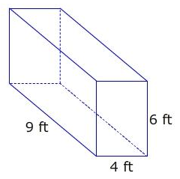
Jake wanted to win the gift card, so he entered the contest. Here is what Jake submitted:

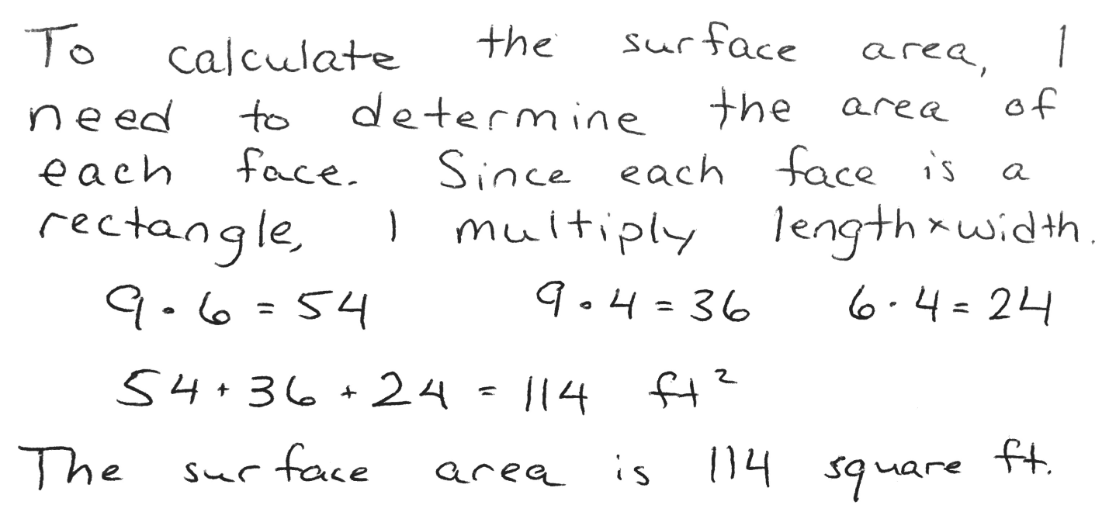
The contest officials need to determine whether Jake qualifies for a $25 gift card, and they want your advice. Write an argument for the officials stating whether you agree or disagree with Jake, and why. Be sure to include supporting evidence.

I agree / disagree (circle one) with Jake because _____________________________
______________________________________________________________________________
______________________________________________________________________________
______________________________________________________________________________
______________________________________________________________________________
______________________________________________________________________________
______________________________________________________________________________
______________________________________________________________________________
______________________________________________________________________________
______________________________________________________________________________
______________________________________________________________________________
______________________________________________________________________________
______________________________________________________________________________
______________________________________________________________________________
______________________________________________________________________________
______________________________________________________________________________
______________________________________________________________________________
______________________________________________________________________________
______________________________________________________________________________

