Name: _______________________________________ Date: ___________________

Ice Cream Engineers

Keebler is currently developing a new experimental ice cream cone that is sealed on all sides, but has ice cream inside! This revolutionary design would allow snackers to put their ice cream cones flat on the table while eating. Their current blueprint for the cone’s design is as follows:

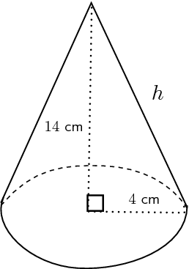

To determine if their design is viable, Keebler hired two engineers, Ben and Jerry, to calculate how much material would be required for these new cones. Ben and Jerry know for a fact that for cones,$surface area= πrs+πr^{2}$. Here is what they came up with:

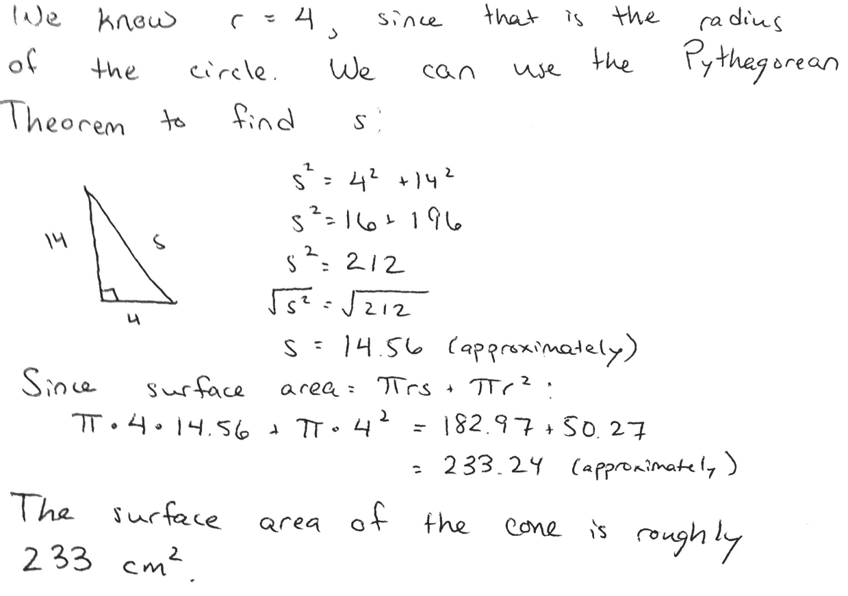
Keebler is worried that Ben and Jerry may actually be working for a competitor, but they aren’t sure. Are Ben and Jerry doing honest work, or are they trying to sabotage the company? Write an argument for Keebler stating whether you agree or disagree with Ben and Jerry, and why. Be sure to include supporting evidence.

I agree / disagree (circle one) with Ben and Jerry because _____________________
______________________________________________________________________________
______________________________________________________________________________
______________________________________________________________________________
______________________________________________________________________________
______________________________________________________________________________
______________________________________________________________________________
______________________________________________________________________________
______________________________________________________________________________
______________________________________________________________________________
______________________________________________________________________________
______________________________________________________________________________
______________________________________________________________________________
______________________________________________________________________________
______________________________________________________________________________
______________________________________________________________________________
______________________________________________________________________________
______________________________________________________________________________
______________________________________________________________________________

