Name(s): ___________________________________________________ Date: ____________
- Using the chart of angle measures, name two pairs of supplementary angles in the diagram where one pair is adjacent and one pair is nonadjacent.
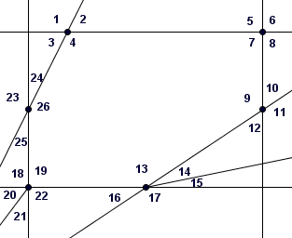
- Construct a viable argument to convince me that each pair is supplementary.
Angle | Measure
$$∠1$$
$$∠2$$ | $$55°$$
$$∠3$$
$$∠4$$
$$∠5$$
$$∠6$$
$$∠7$$
$$∠8$$ | $$90°$$
$$∠9$$ | $$145°$$
$$∠10$$
$∠1$1
$$∠12$$
$∠1$3 | $$120°$$
$$∠14$$
$∠1$5 | $$10°$$
$$∠16$$
$∠1$7
$$∠18$$
$∠1$9
$$∠20$$
$$∠21$$ | $$30°$$
$$∠22$$ | $$90°$$
$$∠23$$
$$∠24$$
$$∠25$$
$$∠26$$ | $$145°$$
1.__________________________________________________________________________________________________________________________________________________________
2._________________________________________________________________________________________________________________________________________________________

