Name: _______________________________________ Date: ___________________

30... 60... 90... Go!

Dwayne is a geometry student practicing his special right triangle skills. He has encountered the triangle shown below, and wants to do some calculations:
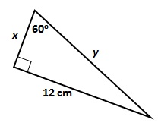
Dwayne tried to find the hypotenuse of this triangle, also known as y. This is what he did:
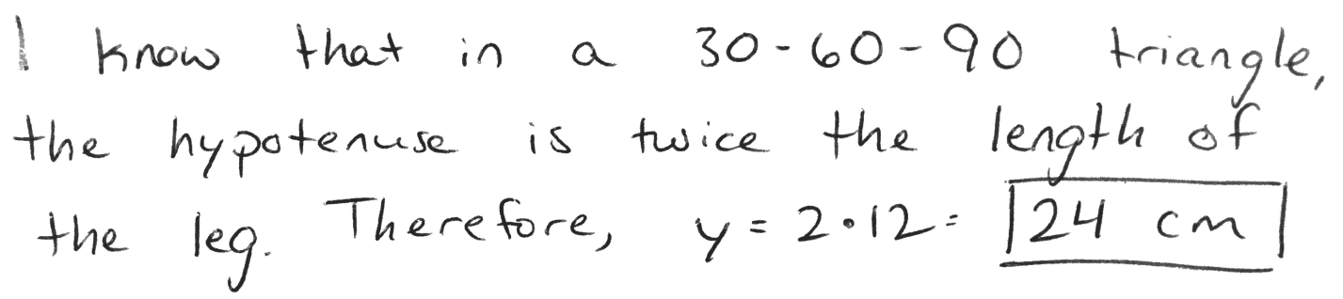
Dwayne isn’t sure that his work is correct, and he wants your advice. Write an argument for Dwayne stating whether you agree or disagree, and why. Be sure to include supporting evidence. Use the Argument Writing Frame as a rough draft, then write your final argument below.

I agree / disagree (circle one) with Dwayne because __________________________
______________________________________________________________________________
______________________________________________________________________________
______________________________________________________________________________
______________________________________________________________________________
______________________________________________________________________________
______________________________________________________________________________
______________________________________________________________________________
______________________________________________________________________________
______________________________________________________________________________
______________________________________________________________________________
______________________________________________________________________________

