Name: __________________________________ Date: _______________ Period: ___________

Honors Geometry – Special Right Triangles Warm-Up

Directions: Using what you know about special right triangles, find the missing variables.
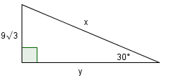
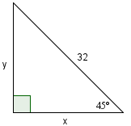
1. 2.

x = ______ y = ______ x = ______ y = ______

3. Now, consider the value you found for x in #1. How do you know your value is correct?

________________________________________________________________________________________________________________________________________________________________________________________________________________________________________________________________________________________________________________________

