Name: Date: Period:

Geometry – Special Right Triangles Warm-Up
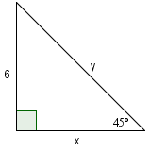
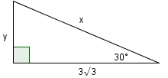
Directions: Using what you know about special right triangles, find the missing variables. 1. 2.

x =

y =

x =

y =

3. Now, consider the value you found for x in #1. How do you know your value is correct?

