Name: __________________________________ Date: _______________ Period: ___________
Geometry – Pythagorean Theorem & Special Right Triangles Exit Slip

Directions: Find the missing side lengths in each of the following right triangles.

1. b = ______ 2. m = ______ n = ______ 3. p = _____ q = ______
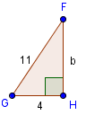
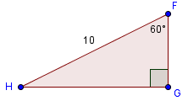
p
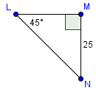
m

n
q

4. Recall the value you found for b in #1. Write a mathematical argument to justify your answer.

________________________________________________________________________________________________________________________________________________________________________________________________________________________________________________________________________________________________________________________
5. Use the given information in the following diagram to find the length of$\overline{DC}$.
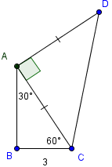

DC = ______

