Name: _________________________________________ Date: ___________________

Not in my Backyard!

Marshall is drawing a scale model of his yard. He draws his front yard (labelled F) and his back yard (labelled B) and he notices that they are both triangles. The models for his front and back yards are shown below.

10

7

8
B
5
F

14
11

Marshall thinks his front and back yards might be similar triangles, so he does some math to figure it out. His work is shown below.

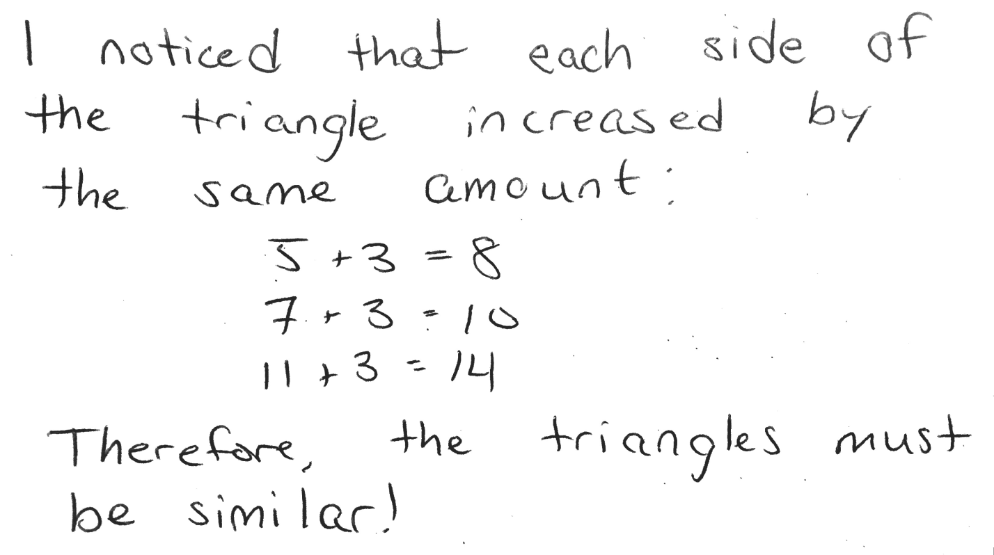

Do you agree or disagree with Marshall? Write an argument using supporting evidence. Use the argument writing frame to draft your argument, and then use the space below to write your final draft.

I agree / disagree (circle one) with Marshall because _________________________
______________________________________________________________________________
______________________________________________________________________________
______________________________________________________________________________
______________________________________________________________________________
______________________________________________________________________________
______________________________________________________________________________
______________________________________________________________________________
______________________________________________________________________________
______________________________________________________________________________
______________________________________________________________________________
______________________________________________________________________________
______________________________________________________________________________
______________________________________________________________________________
______________________________________________________________________________
______________________________________________________________________________

