Name: _________________________________________ Date: ___________________

Casting Shadows

Kyle and Stan are two fourth graders that are curious about their heights. They know that Stan is 4 feet tall, but they aren’t sure how tall Kyle is. When Stan is out in the sun, his shadow is 2 feet long. Kyle can also see that his own shadow is 3 feet long.

Stan has an idea; what if they use similar triangles? Stan says Kyle can determine his height by comparing the triangles that the two of them make with their shadows.
Kyle
Stan

4

x

2
3

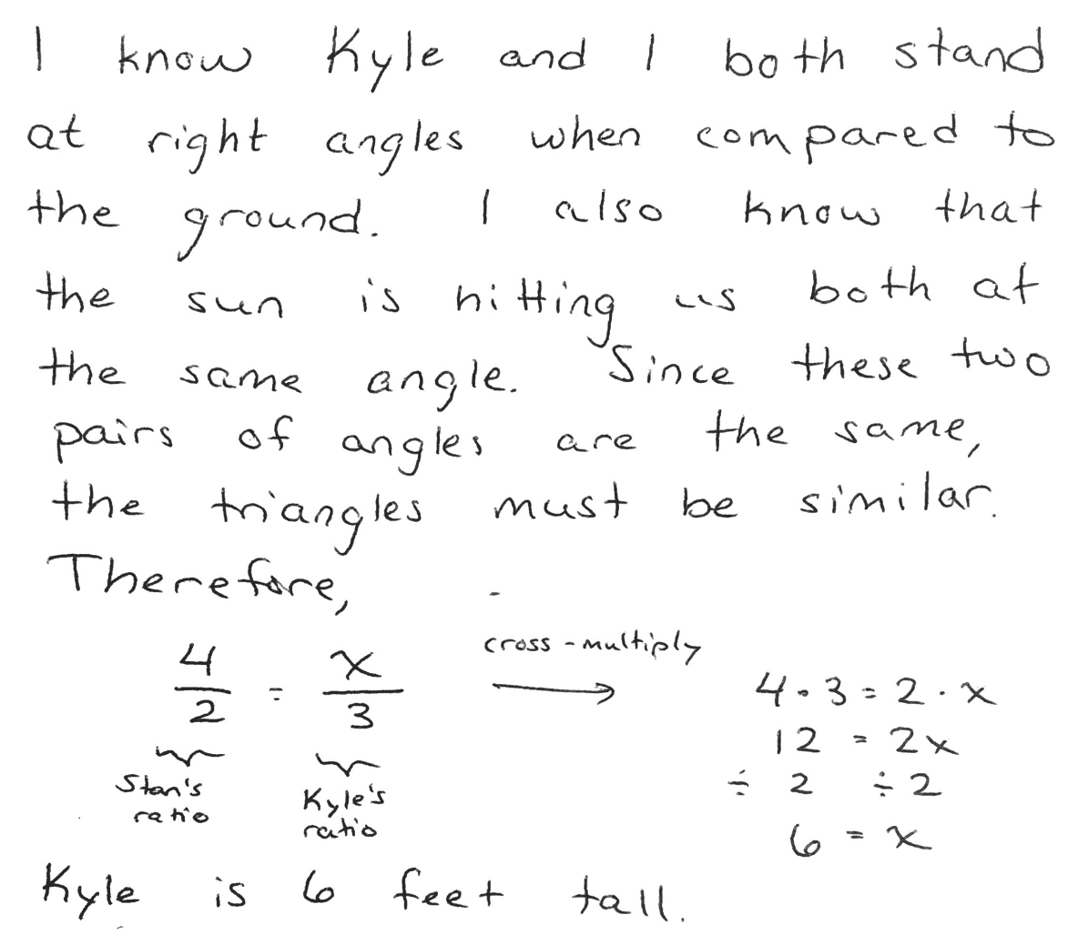
Do you agree or disagree with Stan’s evaluation of Kyle’s height? Write an argument for Kyle to let him know if you think Stan is correct or incorrect. Be sure to include supporting evidence.

I agree / disagree (circle one) with Stan because _____________________________
______________________________________________________________________________
______________________________________________________________________________
______________________________________________________________________________
______________________________________________________________________________
______________________________________________________________________________
______________________________________________________________________________
______________________________________________________________________________
______________________________________________________________________________
______________________________________________________________________________
______________________________________________________________________________
______________________________________________________________________________
______________________________________________________________________________
______________________________________________________________________________
______________________________________________________________________________
______________________________________________________________________________

