Name: __________________________________ Date: _______________ Period: ___________
Geometry – Similarity & Dilations Warm-Up
1. Determine if the triangles are similar. If so, give the scale factor and similarity statement.
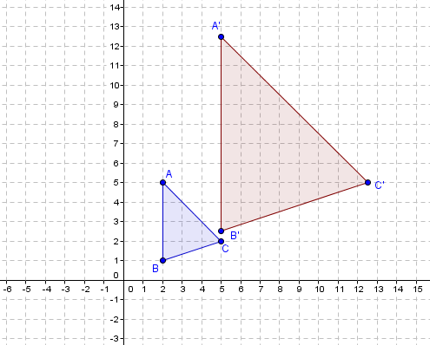

2. Using what you know about the triangle similarity theorems, explain why your answer from #1 is correct.

____________________________________________________________________________________________________________________________________________________________________________________________________________________________________________________________________________________________________________________________________________________

