Name: ___________________________________ Date: ______________ Period: ___________
Geometry – Similarity Exit Slip
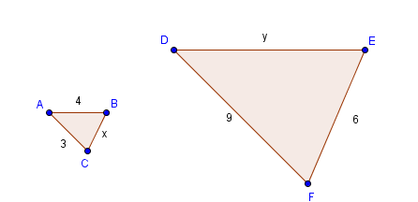
1. $∆ABC$is similar to $∆DEF.$ Find the missing variables and the enlargement scale factor.

x = ______

y = ______

Enlargement Scale Factor: ______

2. Consider the y-value in the above problem. Explain why your y-value is correct.

__________________________________________________________________________________________________________________________________________________________________________________________________________________________________________

