Name: _________________________________ Date: _________________________

Totally Radical!

Rick and Carl are two geometry students that are having an argument over a Pythagorean Theorem problem. The triangle they are arguing over is shown below:

x
4

8

Rick says that $x=4\sqrt{5}$ but Carl is not convinced, since he got a different answer. Carl decided to do some work to show that his answer was correct. Here is what Carl has to say:

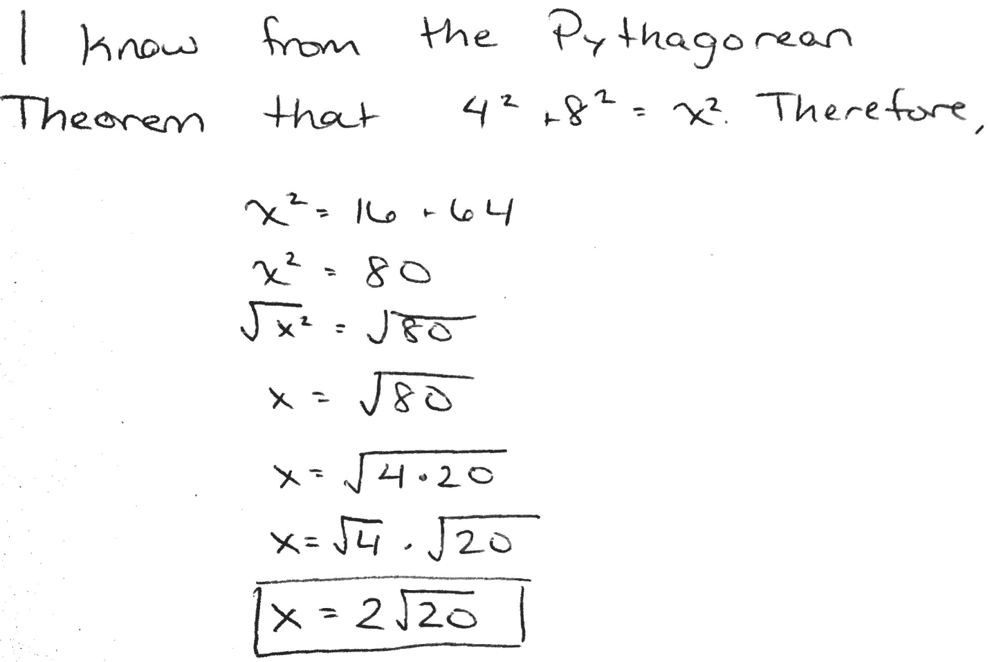

Do you agree or disagree with Carl? Write an argument using supporting evidence. Use the argument writing frame to draft your argument, and then use the space below to write your final draft.

I agree / disagree (circle one) with Carl because _____________________________
______________________________________________________________________________
______________________________________________________________________________
______________________________________________________________________________
______________________________________________________________________________
______________________________________________________________________________
______________________________________________________________________________
______________________________________________________________________________
______________________________________________________________________________
______________________________________________________________________________
______________________________________________________________________________
______________________________________________________________________________
______________________________________________________________________________
______________________________________________________________________________
______________________________________________________________________________
______________________________________________________________________________

