Name: __________________________________ Date: _______________ Period: ___________

Geometry – Pythagorean Theorem Warm-Up

Directions: Using what you know about Pythagorean Theorem, find the missing variables.

1. w = ______ 2. z = ______
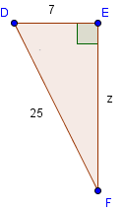
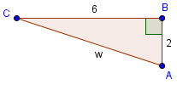

3. Now, consider your answer for z in #2. Write a mathematical argument to justify your answer.

________________________________________________________________________________________________________________________________________________________________________________________________________________________________________________________________________________________________________________________

Name: ______________Key________________ Date: _______________ Period: ___________

Geometry – Pythagorean Theorem Warm-Up

Directions: Using what you know about Pythagorean Theorem, find the missing variables.

1. w = ______ 2. z = ______

1. 6² + 2² = w² 36 + 4 = w² 40 = w² $√40$ = w $√40$ = 2$√10$
2. 7² + z² = 25² 49 + z² = 625 z² = 625-49 z² = 576 $\sqrt{z^{2}}=$ $√576$ z = 24

3. Now, consider your answer for z in #2. Write a mathematical argument to justify your answer.

Because the triangle in #2 is a right triangle, I can use the Pythagorean Theorem to solve for z. I knew I was solving for a leg, so I can put z in for “b” in the Pythagorean Theorem. I set up the equation as 7² + z² = 25² and solved to get z = 24.
The answer should include:
- Using the Pythagorean Theorem because it’s a right triangle
- Identifying the missing side as either the leg or hypotenuse, and connecting it to their equation (“leg means a or b”, “c means hypotenuse”, or z is a leg so I used the equation 7² + z² = 25²)

