Name: ________________________________________ Date: __________ Period: __________

Geometry
Exit Slip – Parallel Lines and Transversals

- Find the measure of < 1 and < 2. Give a reason for you answer.

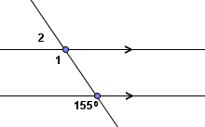
m < 1 = ________ because _______________________________________________________
______________________________________________________________________________
m < 2 = ________ because _______________________________________________________
______________________________________________________________________________
- Find the value of x. Show your work or give a reason for your answer.
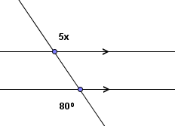
x = ______ because _____________________________________________________________
______________________________________________________________________________

- Donovan was given the following problem and his argument is listed below. However, after handing it in, Donovan did not receive full credit. His argument is below. Explain what Donovan should change to receive full credit.

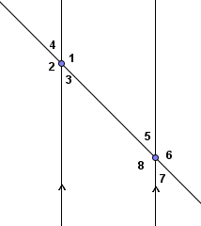
Problem: Given the diagram and m < 4 = 45º, find m < 8 and construct a viable argument that justifies your answer.

Donovan’s Argument:

- m < 4 = 45º because it is given.
- m < 4 + m < 1 =180 º because it forms a straight angle.
- m < 1 = 135 º because 180 º - 45 º = 135 º
- m < 1 = m < 8 because alternate interior angles are congruent.
- m < 8 = 45 º because < 1 and < 8 have the same measure.

______________________________________________________________________________________________________________________________________________________________________________________________________________________________________________________________________________________________________________________________________________________________________________________________________

