Name: _______________________________________ Date: ___________________

Firing on all Cylinders

Natasha loves to drink Coca Cola. However, she wants to know how much Coke she drinks every day, because she is worried that she drinks too much. Natasha has done some research about the dimensions of one can of Coca Cola:

r = 1 in.
h = 5 in.

Natasha decides that she is okay with drinking 30 cubic inches of Coke every day, but doesn’t want to drink any more than that. She currently drinks 2 cans of Coca Cola per day, and does some work to see if she needs to change her habits.

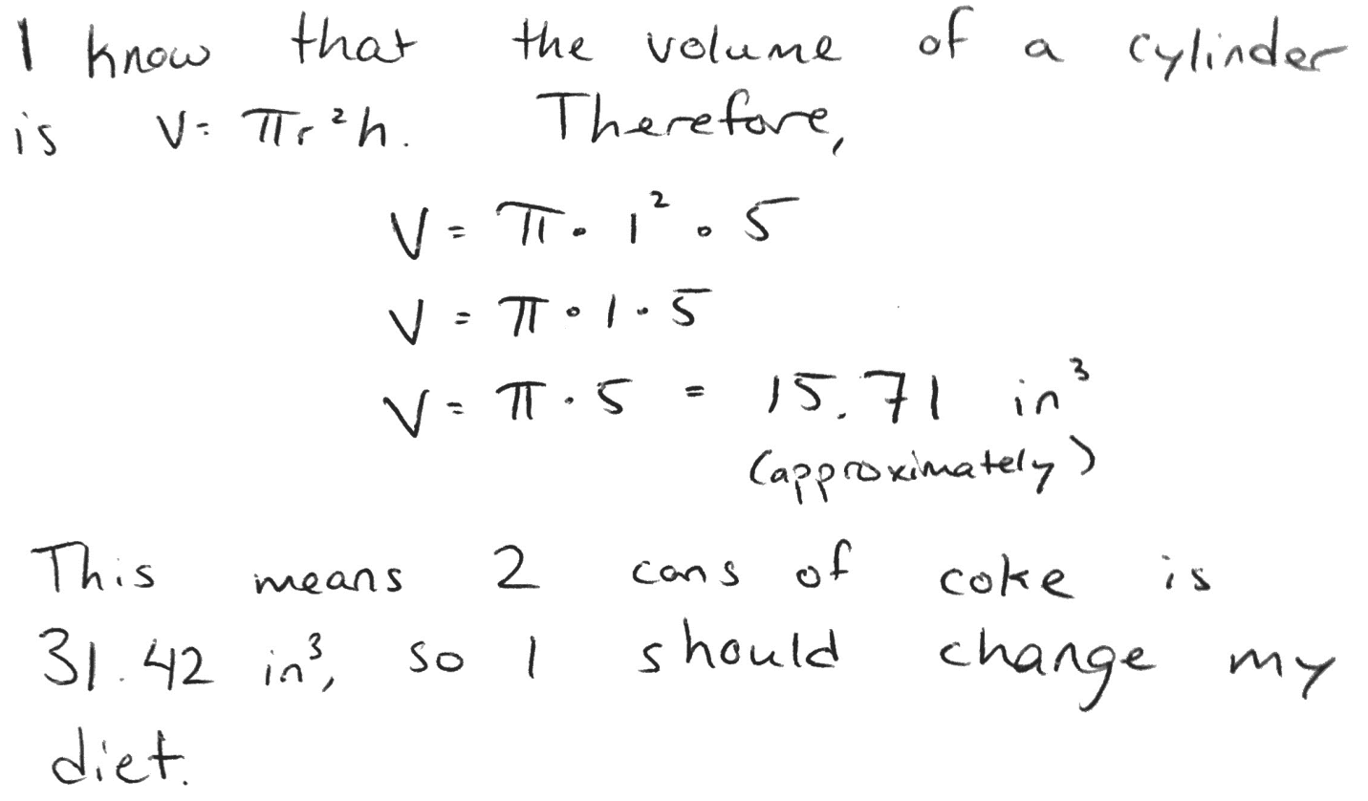
Natasha really likes Coke, and doesn’t like the idea of cutting down on how much she drinks. She wants you to check her work to make sure her assessment is correct. Write an argument for Natasha stating whether you agree or disagree with her, and why. Be sure to include supporting evidence. Use the Argument Writing Frame as a rough draft, then write your final draft below.

I agree / disagree (circle one) with Natasha because __________________________
______________________________________________________________________________
______________________________________________________________________________
______________________________________________________________________________
______________________________________________________________________________
______________________________________________________________________________
______________________________________________________________________________
______________________________________________________________________________
______________________________________________________________________________
______________________________________________________________________________
______________________________________________________________________________
______________________________________________________________________________
______________________________________________________________________________
______________________________________________________________________________
______________________________________________________________________________
______________________________________________________________________________
______________________________________________________________________________
______________________________________________________________________________
______________________________________________________________________________

