Name: Date: Period:
Critiquing Reasoning Problems
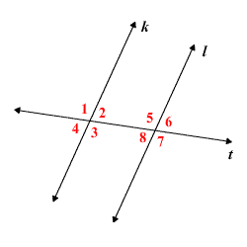
Note: In the following problems, assume that any two lines that do not intersect are parallel.

- In the picture below, there are 8 angles. Jonathan thinks that angles < 1 and < 6 are congruent because they are alternate-exterior angles. Mariah thinks that angles < 1 and < 7 are congruent because they are alternate-exterior angles. Which one is correct? Explain why.

__________________________________________________________________________________________________________________________________________________________________________________________________________________________________________
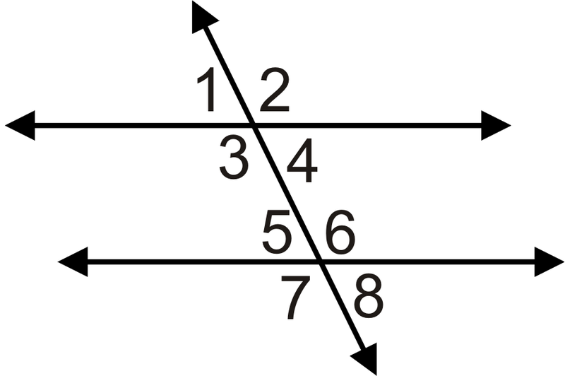
- In the diagram below, Jacqueline thinks that angles < 3, < 4, < 5, and < 6 are all congruent. Josh disagrees, and thinks< 2,
< 3, < 6, and < 7 are all congruent. Which one is correct?
Explain why.

__________________________________________________________________________________________________________________________________________________________________________________________________________________________________________

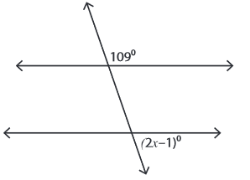
- Given the following picture, Maria wants to use corresponding angles to set up the equation because corresponding angles are congruent. Aubrey wants to use same-side exterior angles because same-side exterior angles add up to 180°. Which one is correct? Explain why.

__________________________________________________________________________________________________________________________________________________________________________________________________________________________________________
- Josette and Calvin are both solving the following problem, but are getting different answers. Who has a better argument? Explain why.

Problem: Given that AF and CD are parallel, find the measure of < BED. Construct an argument that justifies your answer.
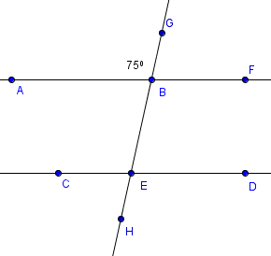
Josette: Because lines AF and CD are parallel, I know that the following pairs are corresponding: < ABG $≃$ < CEB and < GBF $≃$ < BED. Then, since m< ABG = 75°, I know
m < CEB=75°. Since < CEB forms a linear pair with an angle that equals 75°, I know that m< BED is 180°-75°=105 °.

Calvin: AF and CD are parallel, which means their angles are all equal. Because m< ABG = m< CEB, I know that
m< GBF = m< BED. I did 180°-75°=105° and
m< BED = 105° because m< CEB = 75°. I used that the angles add up to 180°because they are supplementary angles.

__________________________________________________________________________________________________________________________________________________________________________________________________________________________________________

