Name: ______________________________ Date: __________________ Period: ____________
Geometry Warm-Up
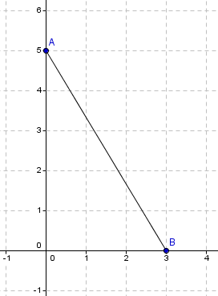
- Find the midpoint of the following segment. Show your work.
Midpoint = ( , )

- Is it possible to have a scalene triangle that is equiangular? Construct an argument that justifies your answer.

__________________________________________________________________________________________________________________________________________________________________________________________________________________________________________
- Classify the triangles by its sides and its angles.


   

