Name: ______________________________ Date: __________________ Period: ____________
Geometry Warm-Up
- Find the midpoint of the following segment. Show your work.
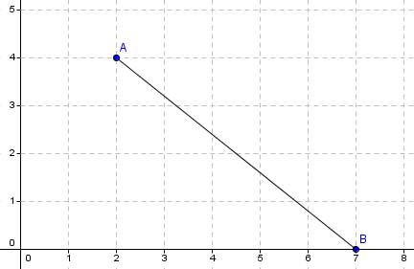
Midpoint = ( , )

- Is it possible to have a triangle with two right angles? Justify your answer.

__________________________________________________________________________________________________________________________________________________________________________________________________________________________________________
- Classify the triangles by sides and angles.


 
 

