Name: ________________________________ Date: _______________ Period: _____________
Geometry--Congruence Postulates

Directions: In each problem, decide whether or not the given triangles are congruent and construct a viable argument that would convince a classmate.
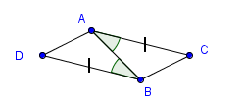
1.
__________________________________________________________________________________________________________________________________________________________________________________________________________________________________________
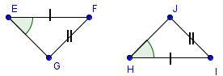
2.
__________________________________________________________________________________________________________________________________________________________________________________________________________________________________________

