Name: ___________________________________ Date: ______________ Period: ___________
Transformations Homework -- Mixed Practice
Directions: Given the pre-image, find two possible ways to get the following image.
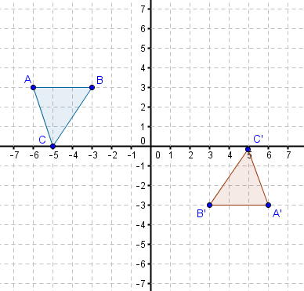
1.
Method 1: ______________
_______________________

Method 2: ______________
_______________________

2. Meredith performed the transformations below. She used a rotation first and then a translation. Verify that her method is possible by describing the transformations she may have used.
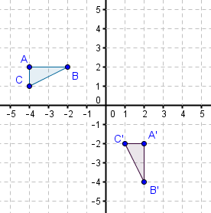
_________________________________________
_________________________________________
_________________________________________
_________________________________________
_________________________________________

3. In the graph below, there is a pre-image and an image, but we do not know how to get from the pre-image to the image. Three students think they found a possible set of transformations. Which student(s) are correct? Construct an argument that justifies your answer.
Jackie: If you rotate $∆ ABC$ 180º clockwise, then you will get the$∆ A'B'C'$.
Joe: If you reflect the pre-image across the y-axis, and then reflect that image across the x-axis, you will get$∆ A'B'C'$.
Damien: If you reflect the pre-image across the x-axis and then rotate that image 90º clockwise, you will get$∆ A'B'C'$.
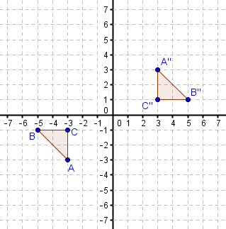

Jackie: _______________________________________________________________________
______________________________________________________________________________

Joe: __________________________________________________________________________
______________________________________________________________________________

Damien: ______________________________________________________________________
______________________________________________________________________________

