Name: _________________________________________ Date: ___________________

Julia’s Reflections

Julia is tired of reflecting over the x and y axes all the time, so she decides to try reflecting some triangles over the line y = x. (shown below as a dotted line) This is what she comes up with:

Reflection 1 Reflection 2
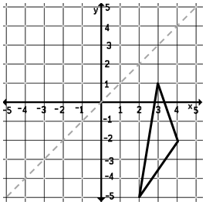
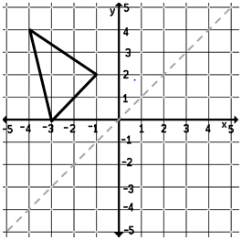
E’
A

D’

B
D
F’

C
B’

E
C’

A’
F

Reflection 3
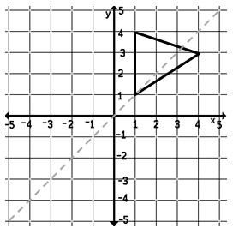
Write in the coordinates of each original
point and its corresponding reflection.
H’
G

H
A: _(-4, 4)____ A’: _(4, -4)____
B: __________ B’: __________
I
C: __________ C’: __________
G’
I’
D: __________ D’: __________
E: __________ E’: __________
F: __________ F’: __________
G: __________ G’: __________
H: __________ H’: __________
I: __________ I’: __________
Do you think Julia’s reflections are correct? Why or why not?
______________________________________________________________________________
______________________________________________________________________________
Julia now wants to come up with a rule for reflecting over the line y = x. Based off of her three reflections, this is what she comes up with:
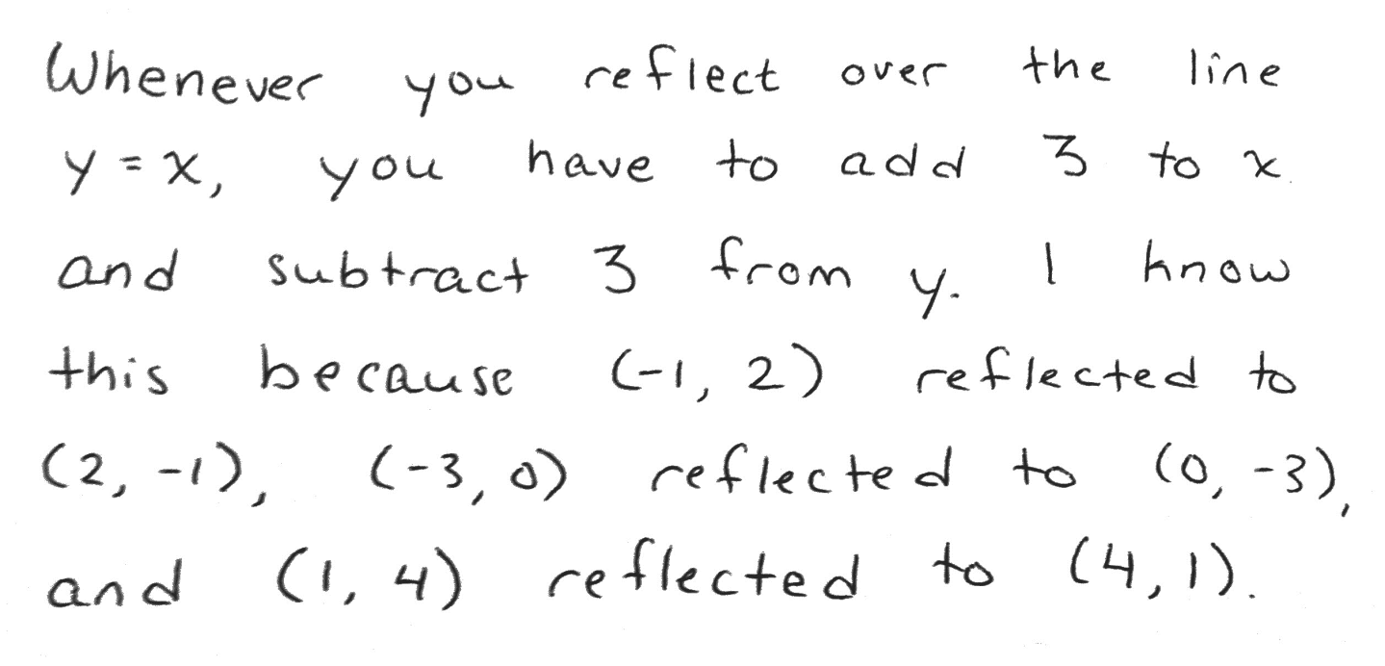
Do you agree or disagree with Julia? Using evidence from her work, write an argument to support why you think she is correct or incorrect.

I agree / disagree (circle one) with Julia because _____________________________
______________________________________________________________________________
______________________________________________________________________________
______________________________________________________________________________
______________________________________________________________________________
______________________________________________________________________________
______________________________________________________________________________

One example that supports / contradicts (circle one) Julia’s pattern is
______________________________________________________________________________
______________________________________________________________________________
______________________________________________________________________________
______________________________________________________________________________
______________________________________________________________________________
______________________________________________________________________________
______________________________________________________________________________
______________________________________________________________________________

