Name: _________________________________ Date: _______________ Period: ____________
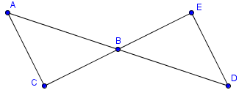
Geometry – Proof Practice
1. Given: $∢ CAB ≅ ∢ EDB,$
$$\overline{AB}≅\overline{DB}$$
Prove: $∆ ABC ≅ ∆ DBE$

Statement | Reason
$$∢ CAB ≅ ∢ EDB$$ | Given
$$\overline{AB}≅\overline{DB}$$ | Given
$$∢ CBA ≅ ∢ EBD$$ | Vertical angles are congruent
$$∆ ABC ≅ ∆ DBE$$ | ASA Postulate
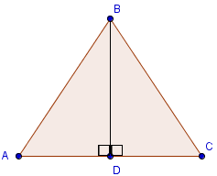
2. Given: D is the midpoint of$\overline{AC}$, $∢ ADB ≅ ∢ CDB$
Prove: $∆ ABD ≅ ∆ CBD$
Statement | Reason
D is the midpoint of $\overline{AC}$ | Given
$$∢ ADB ≅ ∢ CDB$$ | Given
$$\overline{AD}≅ \overline{CD}$$ | Definition of midpoint
$$\overline{BD}≅ \overline{BD}$$ | Reflexive Property
$$∆ ABD ≅ ∆ CBD$$ | SAS Postulate
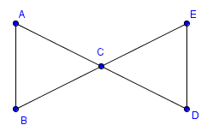
3. Given: C is the midpoint of$\overline{AD}$, C is the midpoint of $\overline{BE}$
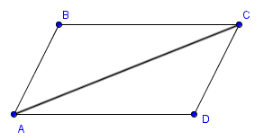
Prove: $∆ ABC ≅ ∆ DEC$
Statement | Reason
C is the midpoint of $\overline{AD}$ | Given
C is the midpoint of $\overline{BE}$ | Given
$$\overline{BC}≅ \overline{EC}$$ | Definition of midpoint
$$\overline{AC}≅ \overline{DC}$$ | Definition of midpoint
$$∢ ACB ≅ ∢ DCE$$ | Vertical angles are congruent
$$∆ ABC ≅ ∆ DEC$$ | SAS Postulate

4. Given:$\overline{BC} || \overline{AD}$, $∢ B ≅ ∢ D$
Prove: $∆ ABC ≅ ∆ CDA$
Statement | Reason
$$\overline{AC} || \overline{DC}$$ | Given
$$∢ ABC ≅ ∢ CDA$$ | Given
$$∢ DAC ≅ ∢ BCA$$ | Parallel lines make Alternate Interior Angles congruent.
$$\overline{AC} ≅ \overline{AC}$$ | Reflexive Property
$$∆ ABC ≅ ∆ CDA$$ | AAS Postulate

