Name_______________________ Date______________

- How can you use the quotient rule of exponents to show why $a^{0}=1, a≠0$?

- ${\left(\frac{x^{8}y^{6}z^{-2}}{xy^{-1}}\right)}^{-4}$ Does it matter if you simplify the expression in the parentheses first and then use the power rule? Or can you use the power rule first and then simplify the expression in the parentheses?

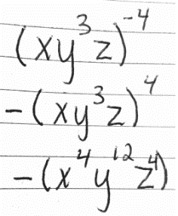
- Use the rule of exponents to critique Kelvin’s work.
$${\left(\frac{x^{2}y^{6}z}{xy^{3}}\right)}^{-4}$$

______________________________________________________________________________
______________________________________________________________________________
______________________________________________________________________________
- Use the rule of exponents to critique Taj’s work.
$${\left(2x^{3}y^{8}\right)}^{4}$$






