Name______________________ Date____________
Simplify the exponential expression. $\frac{6x^{2}y^{6}x^{5}}{24x^{9}y^{3}}$. Use what you know about exponent rules to critique the work of Awa and Austin.
Awa’s work:  $$\frac{{6x}^{2}y^{6}x^{5}}{24x^{9}y^{3}}$$  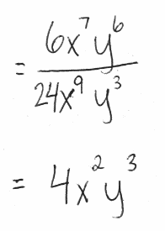 | 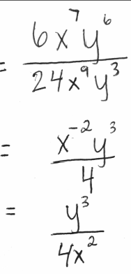  Austin’s work:$$\frac{{6x}^{2}y^{6}x^{5}}{24x^{9}y^{3}}$$
Who do you agree with? How do you know? Use what you know about exponent rules to support and justify your answer.
I agree with ____________________ because __________________________________ ________________________________________________________________________________________________________________________________________________
I know this is true because __________________________________________________ ________________________________________________________________________________________________________________________________________________________________________________________________________________________
____________made a mistake when__________________________________________
________________________________________________________________________
________________________________________________________________________________________________________________________________________________
We Understand ________________________________________________________________________________________________________________________________________________
________________________________________________________________________
Write a mathematical argument to justify your answer. Use complete sentences and correct mathematical vocabulary. Make sure you include:
- Who do you agree with, Awa or Austin?
- Evidence to support who is correct
- Evidence to support who is incorrect
- Warrants (from the We Understand section)

____________________________________________________________________________________________________________________________________________________________________________________________________________________________________________________________________________________________________________________________________________________________________________________________________________________________________________________________________________________________________________________________________________________________________________________________________________________________________________________________________________________________________________________________________________________________________________________________________________________________________________________________________________________________________________________________________________________________________________________________________________________________________________________________________________________________________________________________________________________________________________________________________________________________________________________________________________________________________________

