Name: _________________________________________ Date: ___________________

Multi-Step Equations

Moe, Larry, and Curly are trying to solve the following equation:

4x – 8 = 32

Each student tried to solve for x, but they got three different answers. Their work is shown below:

Moe: Larry: Curly:
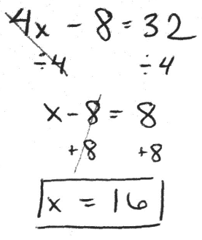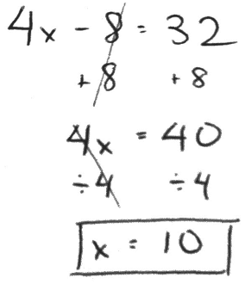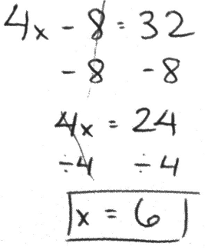

Whose method do you agree with? Write an argument to defend Moe, Larry, or Curly. Be sure to explain any mistakes you believe were made by the students you do not agree with.

I agree with ______________ because ______________________________________________
__________________________________________________________________________________________________________________________________________________________________________________________________________________________________________

I think _____________ made a mistake when ________________________________________
__________________________________________________________________________________________________________________________________________________________________________________________________________________________________________

I think _____________ made a mistake when ________________________________________
__________________________________________________________________________________________________________________________________________________________________________________________________________________________________________

