Name: _________________________________________
Date: ______________ Period: ________

1. Brandy and Raejon were told to determine if $y=2{\left(x+2\right)}^{2}-2x^{2}$ is a quadratic function or not. Their work is shown below:

Brandy Raejon

$y=2{\left(x+2\right)}^{2}-2x^{2}$ $y=2{\left(x+2\right)}^{2}-2x^{2}$
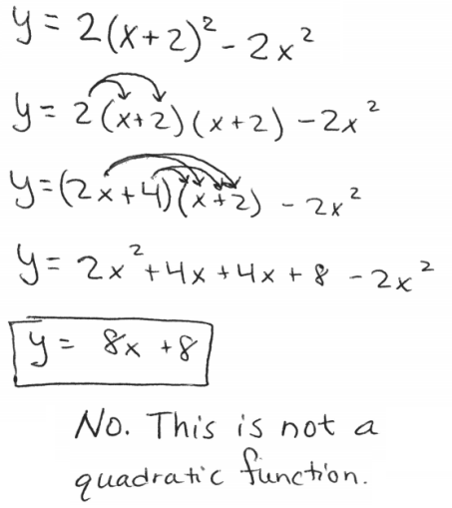
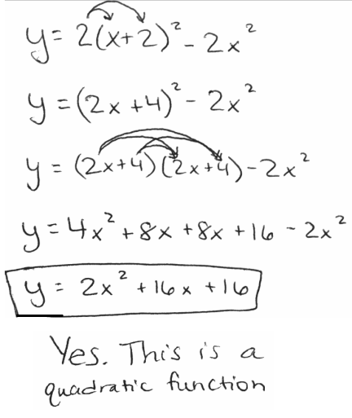

(a) Do you agree with Brandy or Raejon or neither? ____________________________________

(b) Why? Provide evidence and warrants to support your answer.

_________________________________________________________________________________________________________________________________________________

_________________________________________________________________________________________________________________________________________________

_________________________________________________________________________________________________________________________________________________

_________________________________________________________________________________________________________________________________________________

_________________________________________________________________________________________________________________________________________________

_________________________________________________________________________________________________________________________________________________

_________________________________________________________________________________________________________________________________________________

_________________________________________________________________________________________________________________________________________________

_________________________________________________________________________________________________________________________________________________

_________________________________________________________________________________________________________________________________________________

We Understand:
_________________________________________________________________________________________________________________________

_________________________________________________________________________________________________________________________________________________

_________________________________________________________________________________________________________________________________________________
c) Write a mathematical argument to support your claim in part (a). We will use the argument rubric to grade your writing.

Consider the following when writing your argument:

- CLAIM: Do you agree with Brandy or Raejon or neither?
- EVIDENCE: Explain why. Who made a mistake? When? Show your work!!
- WARRANT: Math facts and definitions to support your evidence. (We Understand on front)
- Use complete sentences, correct math vocabulary, and be SPECIFIC.

_________________________________________________________________________________________________________________________

_________________________________________________________________________________________________________________________

_________________________________________________________________________________________________________________________

_________________________________________________________________________________________________________________________

_________________________________________________________________________________________________________________________

_________________________________________________________________________________________________________________________

_________________________________________________________________________________________________________________________

_________________________________________________________________________________________________________________________

_________________________________________________________________________________________________________________________

_________________________________________________________________________________________________________________________

_________________________________________________________________________________________________________________________

_________________________________________________________________________________________________________________________

_________________________________________________________________________________________________________________________

_________________________________________________________________________________________________________________________

_________________________________________________________________________________________________________________________

_________________________________________________________________________________________________________________________

_________________________________________________________________________________________________________________________

_________________________________________________________________________________________________________________________

