Name_____________________________ Date__________
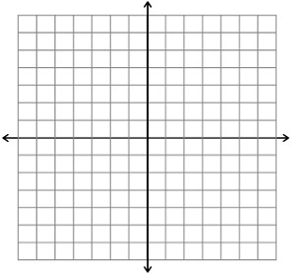
Kendall wants to see if the following ordered pairs make a function: (1, 3) (5,-4) (-3,-4), and (-5, 2). He uses both a map and a graph to solve this problem. Kendall tells Mr. Tierinni that it is a function when he maps it, but it is not a function when he graphs it. Critique Kendall’s work and write a mathematical argument to show whether the ordered pairs make a function.

3
-4

2
1
5
-3
-5

S

________________________________________________________________________________________________________________________________________________________________________________________________________________________________________________________________________________________________________________________________________________________________________________________________________________________________________________________________________________________________________________________________________________________

