Name: _______________________________ Date: ________________
Think

Kendall wants to see if these ordered pairs make a function: (1, 3) (5,-4) (3,-4), and (-7,2). He uses both a map and a graph to solve this problem, but his work shows two different answers. Critique Kendall’s work and write a mathematical argument to show whether the ordered pairs make a function.

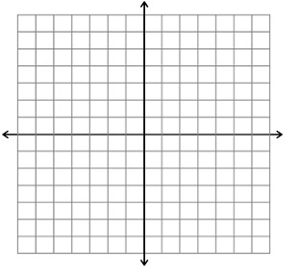

Talk Idea

Talk Idea

Talk Idea

We Understand
The connection between mapping and graphing for functions

