Three of the following four representations are function. Which is not a function? Justify your answer and include reasoning for why it is not a function and why the others are a function.
Input | Output
-3 | 7
6 | 5
-4 | -4
0 | -1
1 | 5
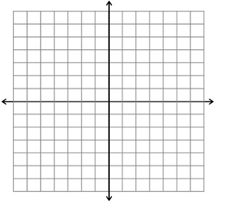
(-3,7) (6,5) (-4,-4) (0,-1) (1,5)
7
5
-4
-1

-3
6
-4
0
1

_____________________________________________________________________________________________________________________________________________________________________________________________________________________________________________________________________________________________________________________________________________________________________________________________________________________________________________________________________________________

