Name: _________________________________
Period: _________
Steepness
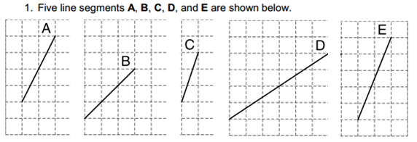
1, 2, 3, 4, 5

5
1
4
3
2

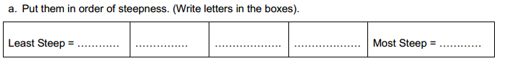

b. Explain your method.
_________________________________________________________________________________________________________________________

_________________________________________________________________________________________________________________________

_________________________________________________________________________________________________________________________

c. What do we need to find to determine how steep a line is?

d. How do we find the slope of a line given a graph?

e. How do we find the slope of a line given two points?

f. How do we determine which line is most steep?

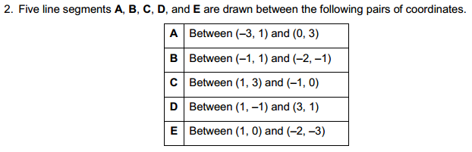

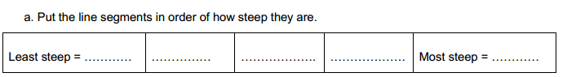
Show your work below:

b. Explain your work and how you know your slopes in the table are correct.

_________________________________________________________________________________________________________________________

_________________________________________________________________________________________________________________________

_________________________________________________________________________________________________________________________

_________________________________________________________________________________________________________________________

_________________________________________________________________________________________________________________________

_________________________________________________________________________________________________________________________

c. How can you check your slopes in part 2a? ______________________________________________________________________
3a. Graph each line below by plotting the two points and connecting the dots.

LINE A LINE B
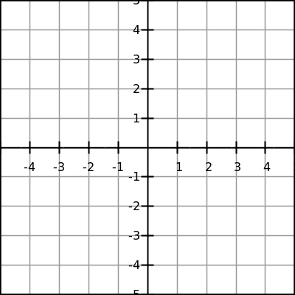

$$\frac{rise}{run}=$$
$$\frac{rise}{run}=$$

LINE C LINE D

$$\frac{rise}{run}=$$
$$\frac{rise}{run}=$$

LINE E

$$\frac{rise}{run}=$$

b. Put the line segments in order of how steep they are.

c. Does this match your answer in part 2a? ___________________

What does that tell you? ______________________________________________________________________________________

____________________________________________________________________________________________________________________________________________________

____________________________________________________________________________________________________________________________________________________
4. Write the equation of each line below in slope-intercept form ($y=mx+b$). Show your work.

a. Equation of Line A: __________________________________ b. Equation of Line B: __________________________________

c. Equation of Line C: __________________________________ d. Equation of Line D: __________________________________

e. Equation of Line E: __________________________________

f. Explain how you found the equation of each line. _______________________________________________________________

___________________________________________________________________________________________________________________________

___________________________________________________________________________________________________________________________

___________________________________________________________________________________________________________________________.

g. Using a DIFFERENT method than what you described above, find the equation of Line A in slope-intercept form ($y=mx+b$). Show your work.

h. Which method do you prefer? Why? _______________________________________________________________________________

___________________________________________________________________________________________________________________________

