Name: _________________________________________ Date: ___________________

The Pizza Problem

Stephen wants to order a pizza to share with his friends Amy and Dan. A pizza from Domino’s costs $4 plus $2 per topping.

1. Write a function to describe the total cost of the pizza.

2. Dan is willing to chip in $2 for the pizza. Write a function to describe how much money Dan will pay for his share of the pizza.

3. Amy is willing to chip in $1 for each topping Stephen orders. Write a function to describe how much money Amy will pay for her share of the pizza.

Arnold wrote the following function to explain how much Stephen pays:

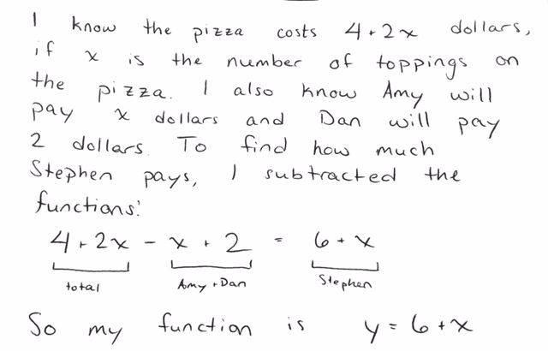

Do you agree or disagree with Arnold? If you agree, explain why. If you disagree, explain what mistake you think Arnold made, and write your own function to describe how much Stephen pays.

I agree / disagree (circle one) with Arnold because ___________________________
______________________________________________________________________________
______________________________________________________________________________
______________________________________________________________________________
______________________________________________________________________________
______________________________________________________________________________
______________________________________________________________________________

My function for how much Stephen pays: ____________________________________________

