Name: _________________________________________ Date: ___________________

Falling Leaves

Jason has noticed that every day, more leaves are falling down into his yard. Over the past few days, he has observed the following pattern:

Monday (Day 1) | Tuesday (Day 2) | Wednesday (Day 3)
 |  | 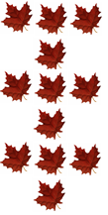
To learn more about the pattern, Jason asked a few questions to his friends, Marcus and Lucy.
Here is Marcus’s response to Jason’s questions:

1. Describe the pattern in your own words.
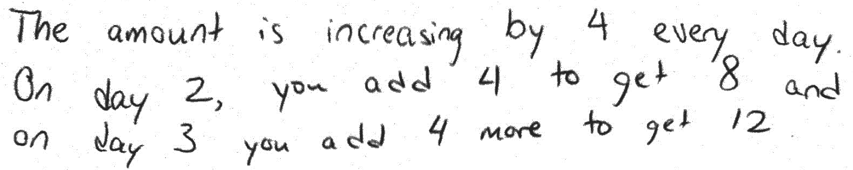
2. How many leaves can Jason expect to fall into his yard on Thursday (day 4)? You may express your answer as a number or as a picture.
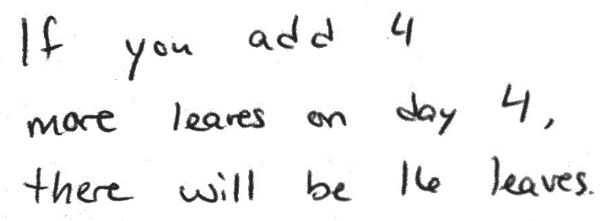
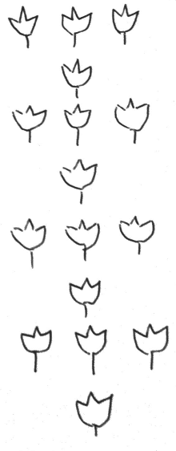
Here is Lucy’s response to Jason’s questions:

1. Describe the pattern in your own words.
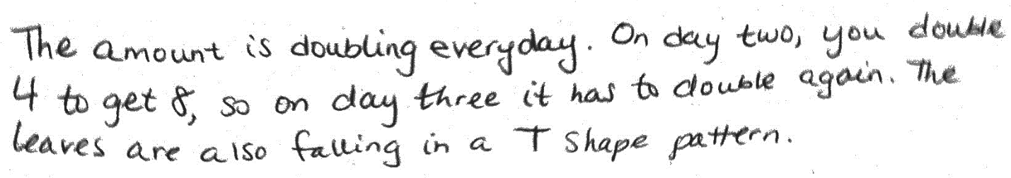
2. How many leaves can Jason expect to fall into his yard on Thursday (day 4)? You may express your answer as a number or as a picture.
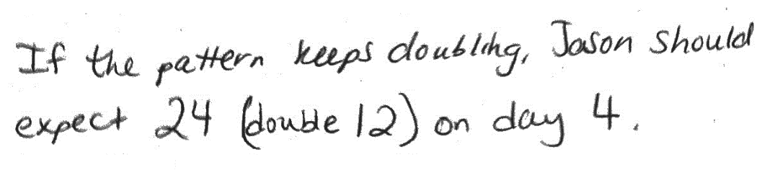
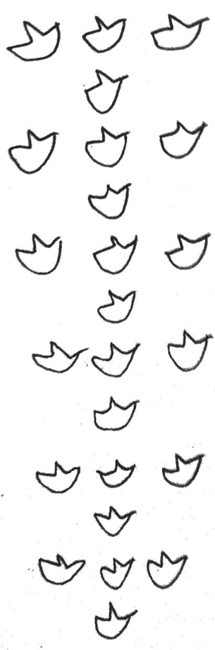

Do you agree with Marcus, Lucy, or neither of them? Write an argument to defend your answer. Be sure to indicate what mistakes you believe each student made.

Response Sheet
I agree with ____________ because ________________________________________________
____________________________________________________________________________________________________________________________________________________________
______________________________________________________________________________

I know this is true because ________________________________________________________
______________________________________________________________________________
______________________________________________________________________________
______________________________________________________________________________

I think ____________ made a mistake when _________________________________________
______________________________________________________________________________
______________________________________________________________________________
______________________________________________________________________________

______________________________________________________________________________
______________________________________________________________________________
______________________________________________________________________________
______________________________________________________________________________

