College Preparatory Mathematics Chapter 9 Sample Argumentation Task

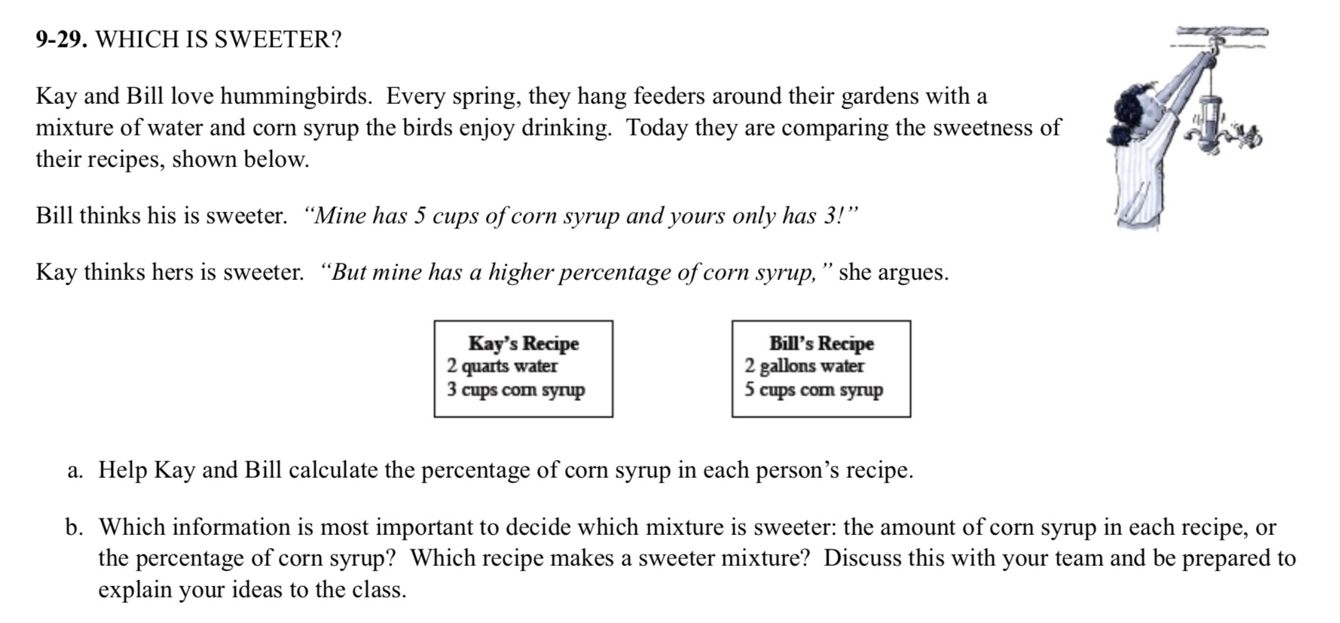
This last sample can be adjusted to be a HIGH QUALITY argument task. The scenario has two characters with opposing views and provides visuals to help students create evidence and work out their reasoning. If used as an argument task, I would shy away from using part a because it gives the students the strategy to use instead of asking them to develop it on their own. I would simply give the scenario and ask "who is correct? Write an argument to explain your reasoning."

"Kay and Bill love hummingbirds. Every spring they hang bird feeders in their gardens with a mixture of corn syrup and water. Kay's mixture is 2 quarts of water and 3 cups of corn syrup. Bill's mixture is 2 gallons of water and 5 cups of corn syrup. Whose mixture is sweeter? Provide evidence to support your answer, and explain how you know your evidence is correct."

