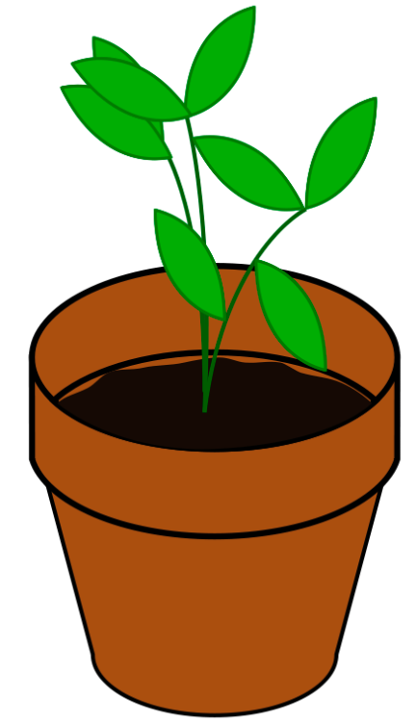
Carlyle’s Plants
Name ______________________________
Date ________________________________

Carlyle feeds the plants in his house with the mixture of liquid plant food and water. This mixture calls for 3 oz of plant food to 8 oz of water. Carlyle has been working with ratios in school and thinks that if he has 40 ounces of water he should have 15 oz of liquid plant food. Is he correct? Justify your answer.

