College Preparatory Mathematics Chapter 7 Sample Argumentation Task

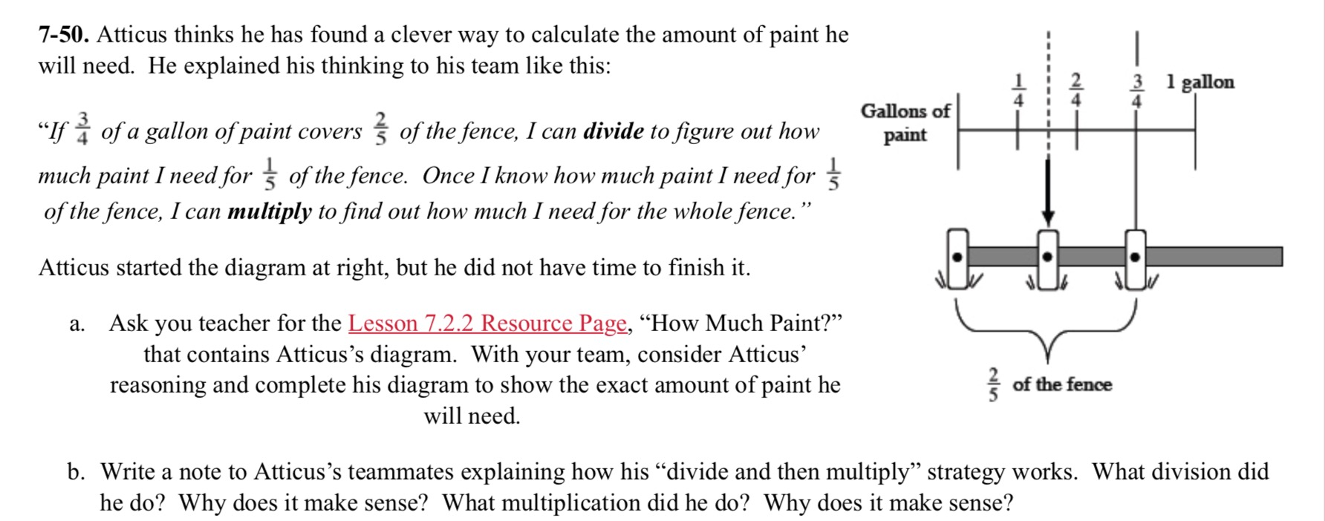

This sample is a HIGH QUALITY argument task. In this example, the character, Atticus, shares a brief argument that explains his work and claim. Then part b of this problem asks students to write to Atticus and explain whether not his strategy works and how. This is a great opportunity for students to assess somebody else's argument and work on critiquing the reasoning of others.

"Atticus thinks he has found a clever way to calculate the amount of paint he will need. "If 3/4 gallons of paint covers 2/5 of the fence, I can divide to figure out how much paint I need for 1/5 of the fence. Once I know how much paint I need for 1/5 of the fence, I can multiply to find out how much I need for the whole fence." Does Atticus' strategy work? Be sure to support your answer using evidence."

