College Preparatory Mathematics Chapter 4 Sample Argumentation Task

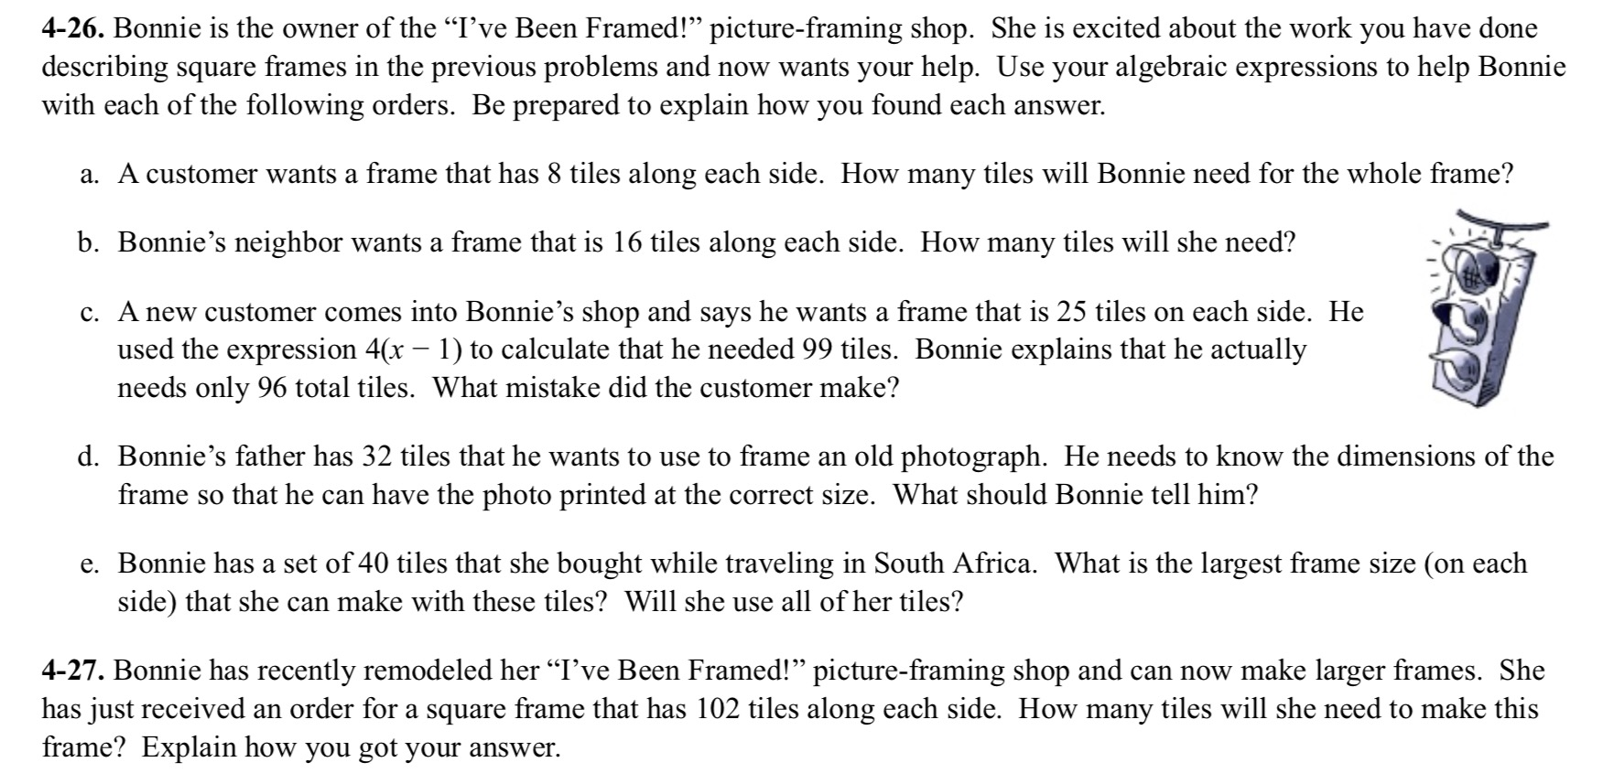
Samples 4-26 and 4-27 can be combined to make a HIGH QUALITY argument task. Part c of 4-26 can be used to help students dispel mathematical misconceptions and once these have been addressed 4-27 can be used as an argument task where students are required to come up with their own claim and then explain how they arrived at their answer using their findings in 4-26 and 4-27.

"Bonnie is the owner of the “I've Been Framed!” picture-framing shop. A new customer comes into Bonnie's shop and says he wants a frame that is 25 tiles on each side. He used the expression 4(x-1) to calculate that he needed 99 tiles. Bonnie explains that he only needs 96 tiles. Who do you agree with? Be sure to explain your thinking, and support your answer with appropriate evidence."

