College Preparatory Mathematics Chapter 7 Sample Argumentation Task

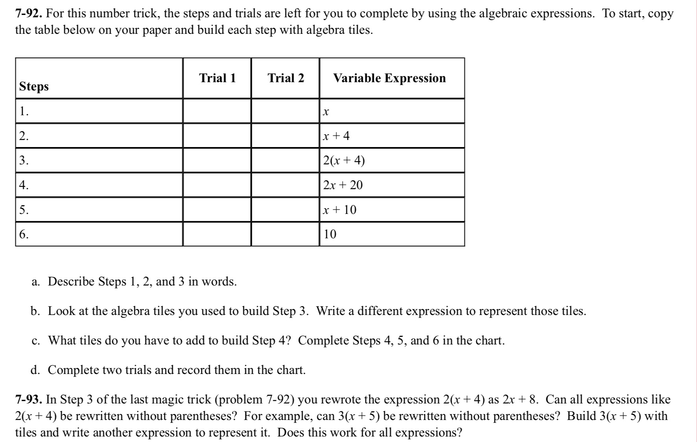
In the above sample, problems 7-92 and 7-93 can be combined to make a HIGH QUALITY argument task. 7-92 provides students with evidence to be used when working on generalizing concepts, using logic and patterns and explaining their reasoning in 7-93. This is also a great opportunity to talk about how to argue that a formula ALWAYS works or how to disprove this.

"Can all expressions like 2(x+4) be rewritten without parenthesis as 2x+8? Use the pattern from problem 7-92 to support your claim. Be sure to explain your reasoning."

