College Preparatory Mathematics Chapter 6 Sample Argumentation Task

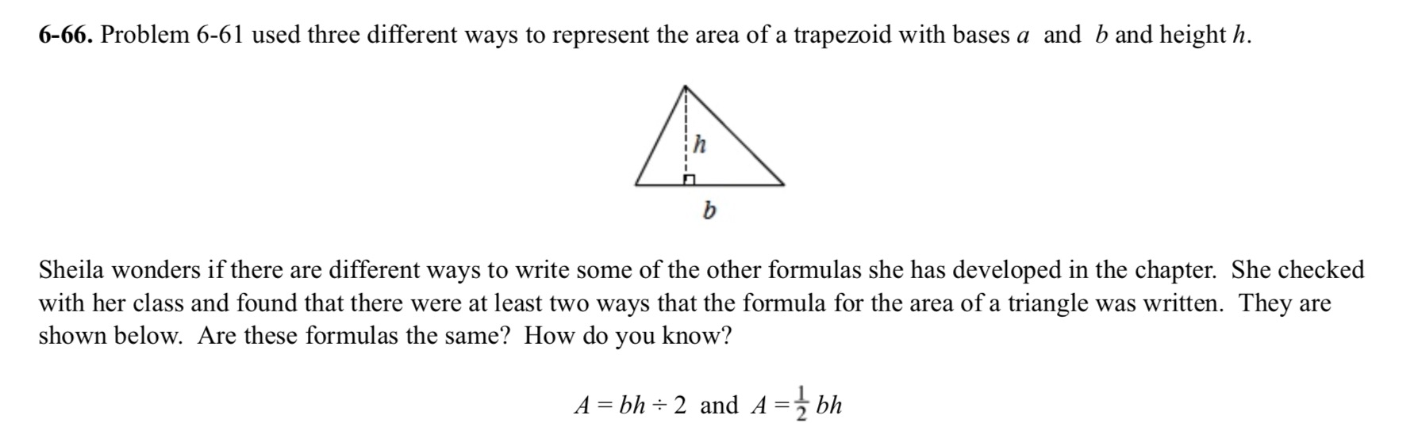
This sample is a HIGH QUALITY argument task. The problem asks students to use logic and divergent thinking as well as algebraic knowledge to assess whether or not two expressions are equivalent. The problem uses a pictorial representation and asks students how they know their answer is correct.

"Sheila believes there are two equivalent formulas for finding the area of a triangle, bh÷ 2 and ½ bh. Do you agree with Sheila's claim? Be sure to explain your reasoning."

