College Preparatory Mathematics Chapter 8 Sample Argumentation Task
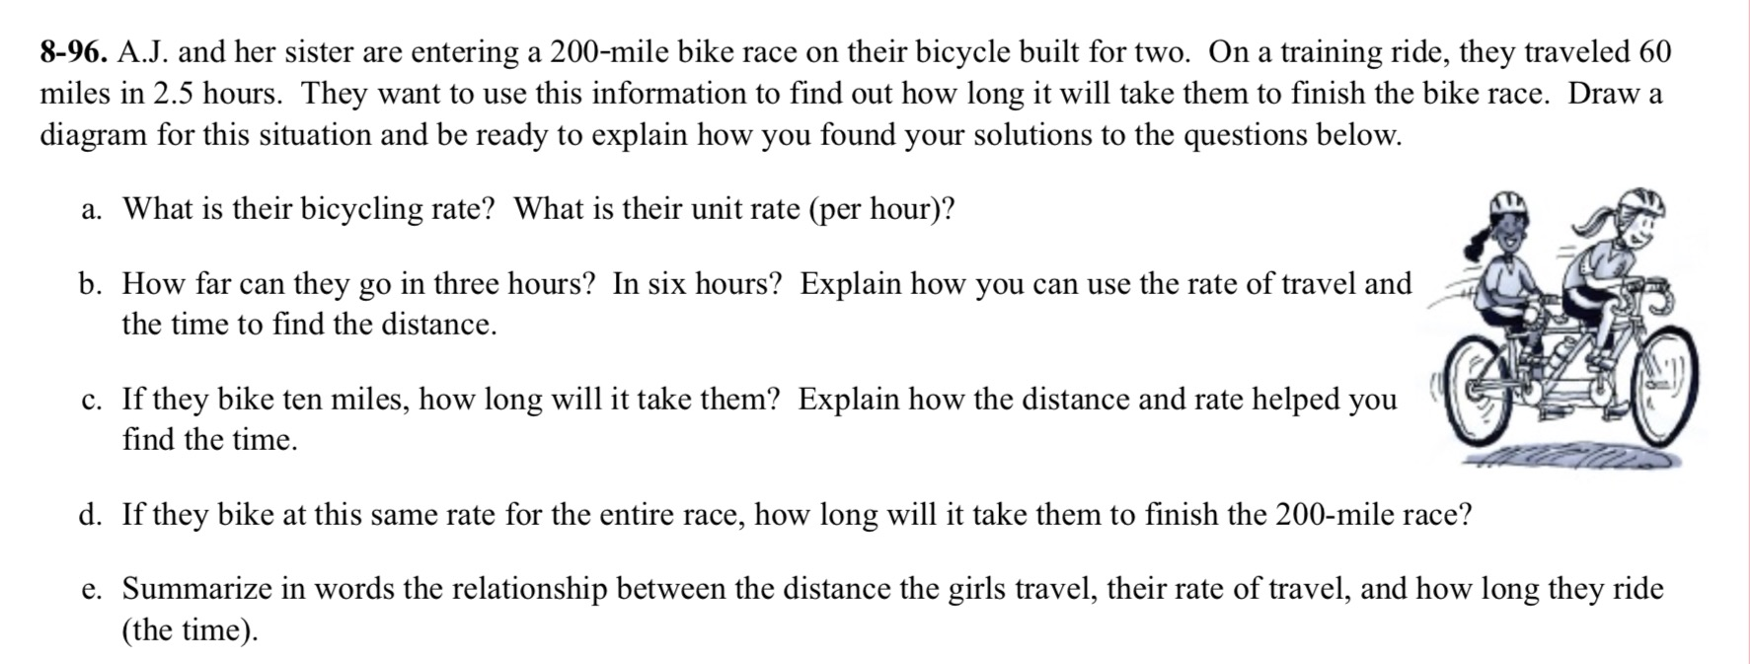
Due to chapter 8's focus on statistical models and analyzing data, there are less opportunities for argument tasks. However, part b in the sample above is an ADEQUATE QUALITY argument task. It requires students to identify patterns and rates of change while also explaining how these can be used to make larger computations simpler.

"A. J. and his sister are entering a 200-mile bike race on their bicycle built for two. In a training ride they traveled 60 miles in 2.5 hours. How far can they travel in 3 hours? What about 6? Explain how the rate of change can help us find how far they traveled in any amount of time. Be sure to use evidence to support your answer and explain your reasoning."

