College Preparatory Mathematics Chapter 1 Sample Argumentation Task
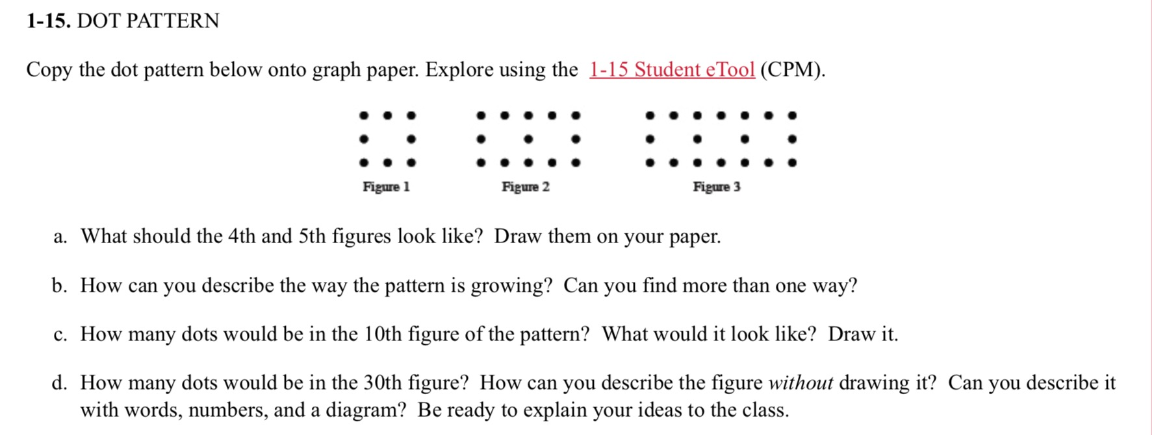

This sample is a HIGH QUALITY argumentation task. The exercise encourages the use of logic and divergent thinking in pattern recognition and leads to the idea of using a mathematical formulas while also requiring the students explain their ideas. While parts a and b can be helpful for framing student thinking and introducing an effective way to think of patterns, it is parts c and d that could be used as one joint argumentation task or two separate tasks.

"How many dots would the in the 30th figure? Analyze the pattern and use pictures or expressions to support your answer. Then explain how your evidence shows your answer is correct."

