College Preparatory Mathematics Chapter 3 Sample Argumentation Task

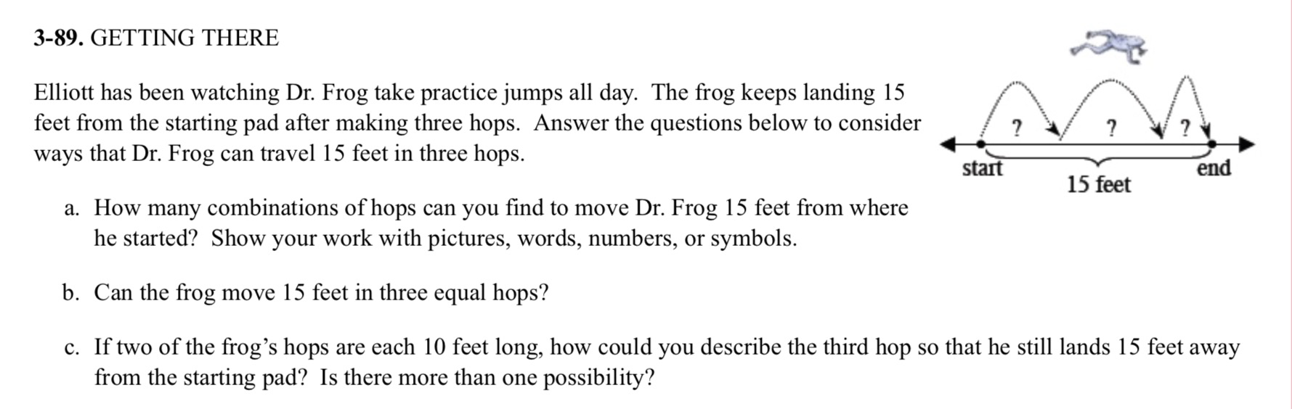
This is an ADEQUATE QUALITY argument task. Part a of the problem explicitly asks students to show their work which will drive students to provide plenty of evidence. However, it does not ask students to also explain their reasoning. If assigned as an argumentation task be sure to explicitly do both to ensure students are writing as well as showing appropriate evidence.

"Elliot has been watching Dr. Frog take practice jumps all day. The frog keeps landing 15 feet from the starting pad after making three hops. How many combinations of hops can move Dr. Frog 15 from where he started? Be sure to explain your thinking, and support your answer with pictures, words, numbers, or symbols."

