Name:----------------------- Date: _ __

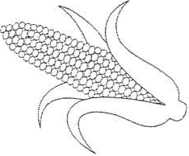Teacher: _______________
Harvesting Corn

Maura and Liam work for the local farm harvesting corn. They harvest about 2 $\frac{2}{\begin{aligned}3 \\ \end{aligned}}$

acres each day. They only have 5 $\frac{1}{2}$
days to harvest the corn.

- Write 2$\frac{2}{3}$ as an improper fraction.

- On day 1of harvesting, Maura harvested 1$\frac{1}{2}$ acres. How much land was left for Liam to harvest?

- During the 5$\frac{1}{2}$ days of harvesting, Maura thinks they can harvest a total of 12 acres for the local farmer.

Do you agree with Maura? Justify your answer.

