College Preparatory Mathematics Chapter 5 Sample Argumentation Task

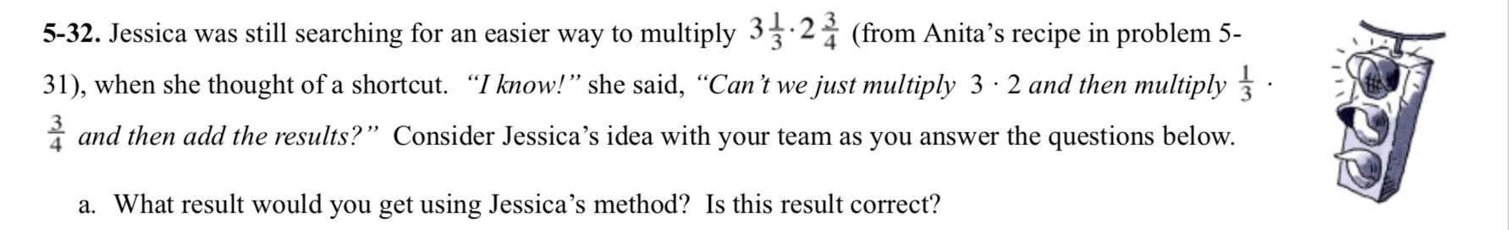
This sample could be a HIGH QUALITY argument task as long as some adjustments are made. It addresses a mathematical misconception many students face. Personally, I would even get rid of the directions to consider Jessica's idea with your team and part a of the problem and simply pose the question to my students about whether or not they agree with Jessica's idea and why or why not.

"Jessica believes she has a shortcut method to multiply 3$\frac{1}{3}$ times 2$\frac{3}{4}$, "Multiply 3 times 2 and then multiply 1/3 times 3/4 and then add the results." Does Jessica's method work for this example? Does it work for any multiplication of mixed numbers? Be sure to provide evidence and explain your reasoning."

