College Preparatory Mathematics Chapter 5 Sample Argumentation Task
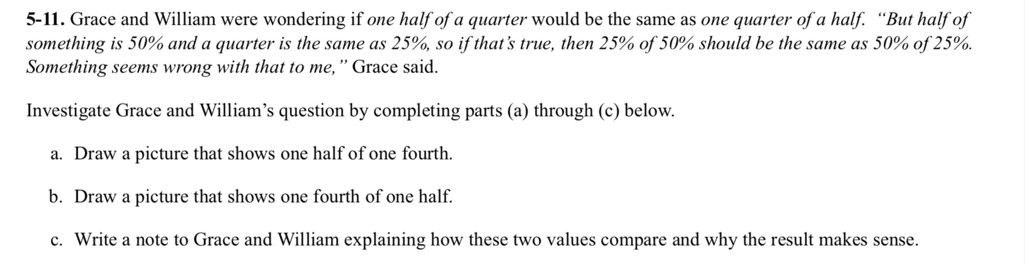
This sample is an ADEQUATE QUALITY argument task. The problem presents us with two students who are confused about a concept and are trying to make sense of it. This is a great problem to focus on the speaking and writing piece since there is not much evidence required.

"Grace and William were wondering if one half of a quarter would be the same as one quarter of a half. "But half of something is 50% and a quarter is the same as 25%, so if that's true, then 25% of 50% should be the same as 50% or 25%. Something seems wrong with that to me," says Grace. Do you agree that one half of a quarter would be the same as one quarter of a half? Help Grace understand your claim by providing evidence and reasoning."

