Name:

Angela’s Idea

When Angela solved the problem x she got an answer of . This confused Carissa. She thought the answer was incorrect because she always thought multiplication results in a product larger than the factors.

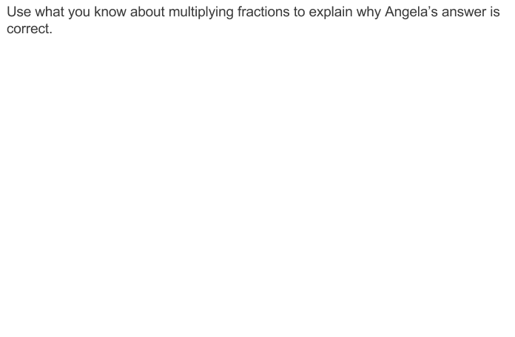

Teacher notes:

A. Comparing the size of a product to the size of one factor on the basis of the size of the other factor, without performing the indicated multiplication.

B. Explaining why multiplying a given number by a fraction greater than 1 results in a product greater than the given number (recognizing multiplication by whole numbers greater than 1 as a familiar case); explaining why multiplying a given number by a fraction less than 1 results in a product smaller than the given number; and relating the principle of fraction equivalence a/b = (n×a)/(n×b) to the effect of multiplying a/b by

Not yet: Student shows evidence of misunderstanding, incorrect concept or procedure |  | Got It: Student essentially understands the target concept.
0 Unsatisfactory:  Little Accomplishment  The task is attempted and some mathematical effort is made. There may be fragments of accomplishment but little or no success. Further teaching is required. | 1 Marginal:  Partial Accomplishment  Part of the task is accomplished, but there is lack of evidence of understanding or evidence of not understanding. Further teaching is required. | 2 Proficient:  Substantial Accomplishment  Student could work to full accomplishment with minimal feedback from teacher. Errors are minor. Teacher is confident that understanding is adequate to accomplish the objective with minimal assistance. | 3 Excellent:  Full Accomplishment  Strategy and execution meet the content, process, and qualitative demands of the task or concept. Student can communicate ideas. May have minor errors that do not impact the mathematics.
Adapted from Van de Walle, J. (2004) Elementary and Middle School Mathematics: Teaching Developmentally. Boston: Pearson Education, 65

